# Nova Scotia Multi Library Audit Report

**For:** Acadia University (Maggie Jean Neilson) and Novanet (Bill Slauenwhite)

**Date:** September 5, 2020

**From:** Lisa Snider, Access Changes Everything (ACE)  
**Contact Information:** (902) 717-5704 or [lisa@AccessChangesEverything.com](mailto:lisa@AccessChangesEverything.com)

Nova Scotia Multi Library Audit Report 1

Audit Information 3

Report Date 3

Reviewer 3

Web Site Information 3

Documents 4

Standard 4

Findings Information 4

Reviewer’s Testing Technologies 5

Third Party Testers 5

Third Party Testers Testing Technologies 6

Questions 6

Thank You 6

Summary of Audit Findings 7

Magnification 7

Small Screens 13

Skip Links 16

Keyboard and Focus 18

Colour 22

Links 26

Font Type, Size and Styling 28

Navigation & Drop Down Menus 31

iFrame 36

Headings 38

Tables 43

Images 46

ARIA Code 50

Lists 53

Search Mechanism 55

Search Results 61

CSS 68

HTML Code Errors 70

Disclaimer 73

Copyright 75

## Audit Information

### Report Date

September 5, 2020

Note: Testing was done from August 15-September 3, 2020

### Reviewer

Lisa Snider from Access Changes Everything (ACE).

### Web Site Information

The following is the report on the full accessibility audit of the following library related web pages that were chosen by the client for auditing:

* Acadia Scholar – landing page <https://scholar.acadiau.ca/> (Acadia Scholar Landing)
* Acadia Scholar -  Scholar profiles <https://scholar.acadiau.ca/scholars> (Acadia Scholar Profiles)
* Acadia Scholar – Theses search results <https://scholar.acadiau.ca/theses> (Acadia Scholar Theses)
* Acadia Scholar – Help page <https://scholar.acadiau.ca/help> (Acadia Scholar Help)
* Acadia Scholar – Contact <https://scholar.acadiau.ca/contact> (Acadia Scholar Contact)
* Acadia Scholar – Thesis example <https://scholar.acadiau.ca/islandora/object/theses%3A3271> (Acadia Scholar Thesis)
* Acadia Scholar – Advanced search <https://scholar.acadiau.ca/advanced-search> (Acadia Scholar Advanced Search)
* Chipman’s Corner -Digital collections <https://chipmanscorner.acadiau.ca/collections> (Chipman's Corner Digital Collection)
* Chipman’s Corner – Image record example  <https://chipmanscorner.acadiau.ca/islandora/object/research%3A1250> (Chipman's Corner Image Record)
* Chipman’s Corner – Document record example <https://chipmanscorner.acadiau.ca/islandora/object/research%3A427> (Chipman's Corner Document Record)
* Library Homepage <https://library.acadiau.ca/home.html> (Acadia Library Home)
* Website search <https://library.acadiau.ca/search.html?query=acadia+university> (Acadia Search)
* Library hours <https://library.acadiau.ca/about/hours.html> (Acadia Library Hours)
* Loan periods <https://library.acadiau.ca/about/policies/loan-periods.html> (Acadia Loan Periods)
* Interlibrary loans <https://library.acadiau.ca/borrow/interlibrary-loans.html> (Acadia Interlibrary Loans)
* What’s happening in the Library <https://library.acadiau.ca/whats-happening.html> (Acadia What's Happening)
* Website feedback forms <https://library.acadiau.ca/contact/website-feedback.html> Note: This was not available for full testing, so Acadia Contact Us was tested instead (<https://library.acadiau.ca/contact.html>)
* Our people <https://library.acadiau.ca/about/people.html> (Acadia Our People)
* Finding things in the Library <https://library.acadiau.ca/about/locations.html> (Acadia Finding Things (Locations)

Extensive manual and automated testing of the web pages was completed by ACE, and user testers were employed in this audit to test specific parts of the web pages. Only the public side of the websites were tested, unless login information was provided to test password only areas.

### Documents

Document auditing was not part of this contract. However, one PDF was quickly examined from the Loan Periods page (Open Access), and it was inaccessible for many users.

### Standard

The international standard that relates to website accessibility was considered, which is WCAG 2.1 (2.2 Draft) Level AA. This audit went far beyond WCAG 2.1 and 2.2 (Draft) Level AA, as the standards don’t include many accessibility best practices for people with different disabilities. General usability and accessibility best practices were considered, and included in this audit report.

### Findings Information

Lisa Snider provided a full audit of the web pages, and testers with different disabilities were employed to check specific areas on these web pages.

The web pages would not pass WCAG 2.1, or 2.2, Level AA, as there would be some criteria that would not be given a pass. As well, they may not have included usability and accessibility best practices.

The audit found areas that need improvement in terms of accessibility. The recommendations below have been noted as **\*\*PRIORITY\*\*** and **\*SECONDARY PRIORITY\*** to note their significance, in terms of remediation priorities.

The items marked **\*\*PRIORITY\*\*** should be remediated as soon as possible, as they are currently impacting some users with disabilities in a moderate to severe way. These users may not be able to access all, or any meaningful, information on the website, limiting access to it. The items marked **\*SECONDARY PRIORITY\*** also impact some users with disabilities, but this impact is judged as minimal to moderate for most users.

These categories are arbitrary, and were based on the consultant’s view of the standard, and their experience and knowledge. Please see the Disclaimer for more information.

### Reviewer’s Testing Technologies

* Mac OS Sierra 10.12.6 Firefox and Chrome
* PC Windows 10 Firefox and Chrome
* A minimum of 10 different accessibility related apps, plugins, extensions, as well as online checking software, were used in both Chrome and Firefox on PC and Mac.
* Manual testing was completed, and this included different assistive technologies.

### Third Party Testers

Paid testers were employed for this project. All testers were students at either Dalhousie University, MSVU or Acadia University. They were from both undergraduate, and graduate programs. They were also from different years, and first year undergraduate and graduate students were chosen deliberately were represented well overall.

Below, their information has been anonymized, to protect their identities.

* 2nd year MSVU student, who identified as having visual and hearing disabilities.
* 3rd year older MSVU student, who identified as having ADHD (cognitive disability).
* 3rd year older MSVU student, who identified as having a hearing disability, as well as mobility and perception disabilities.
* 1st year Dalhousie graduate student, who identified as having low vision.
* 1st year Dalhousie student, who identified as having ADD (cognitive disability).
* 1st year Dalhousie student, who identified as having autism, depression and social anxiety.
* 1st year Acadia student, who identified as having panic and anxiety (cognitive disabilities).
* 1st year Dalhousie graduate student, who identified as having a mobility disability and severe migraines.

### Third Party Testers Testing Technologies

Note that some testers did not use any specific technologies. Macs and PCs were represented, one tester used an iPad Pro, and different browsers were used.

* Natural Reader Speech to Text (Google Chrome Extension)
* Phonak Compilot Bluetooth device (to assist hearing).
* VoiceOver screen reader on Google Chrome 83.0.4103.116 on Mac Catalina 10.15.5
* JAWS 2020 Home Use on Google Chrome 83.0.4103.116 on PC Windows 10
* Low vision accessibility features on iPad Pro, including Pinch to Zoom and large text.
* 200% and 400% magnification in Firefox 75.0 browser on Mac OS Sierra (v10.13).
* 200% and 400% magnification in Chrome 80.0.3987.163 (64-bit) on Mac OS Sierra (v10.13).
* Voice Control on iPhone 11 Pro iOS 13.3

### **Questions**

If you have questions about this report, please contact Lisa Snider at [lisa@AccessChangesEverything.com](mailto:lisa@AccessChangesEverything.com).

### **Thank You**

Thank you for allowing Access Changes Everything to provide accessibility consulting services for this project.

## Summary of Audit Findings

#### Magnification

##### Importance and Users Impacted

Web pages need to be tested with 200% and 400% browser magnification applied (at 1280 x 800 resolution as well as 1440 x 900), to ensure all users can access the web pages. The magnification is tested to ensure that everyone who uses magnification (only up to 400%), such as people with low vision and/or other disabilities, can access the site with it enabled.

Note: One tester used pinch to zoom navigation on an iPad. Those results will be found throughout the report, in specific areas where barriers were noted. The results in this section were only from the testing at 200 and 400%.

##### Findings

**Acadia Scholar Landing **PRIORITY\*\***

There was one issue noted at 400% (1440 x 900 resolution). The hamburger main menu at the top of the page can be easily activated. However, on Chrome and Firefox, the menu could not be closed, except if the hamburger menu icon was deliberately pressed. This was not expected, and meant excessive scrolling. This script should be modified, so the menu can be closed with clicking outside of the drop down menu area. Note that the same issue occurred on mobile as well.



**Acadia Scholar Profiles **PRIORITY\*\***

There was one issue noted at both 200% and 400%. In the Scholar Profiles list area, the text was unreadable due to overlapping at 200%, and this was even worse at 400%.

200%

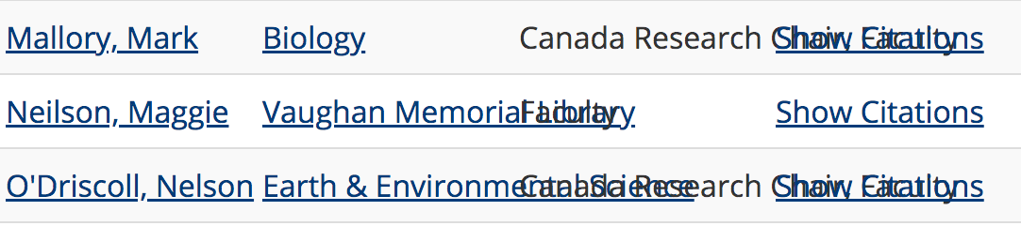

400%

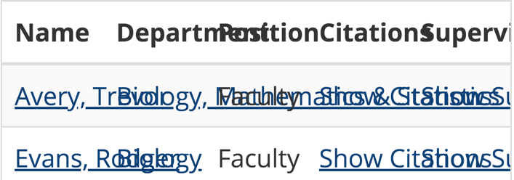

These **MUST** be remediated, so the list can be used without difficulty, or scrolling, on both magnification settings.

There was one issue noted at 400% (1440 x 900 resolution), that involved the hamburger menu icon placement.The menupartially obscures the top banner text. While that text is still readable, it is recommended that the menu location be shifted to below the banner area. Note that this also happens on mobile, but only the Y in the word University is obscured.



**Acadia Scholar Theses Search Results **PRIORITY\*\***

See the two hamburger menu issues noted at 400% (1440 x 900 resolution).One is the menu drop down not being easy to close, which is found in the Acadia Scholar Landing section. The other is the placement of the menu icon noted in the Acadia Scholar Profiles section.

**Acadia Scholar Help **PRIORITY\*\***

See the two hamburger menu issues noted at 400% (1440 x 900 resolution).One is the menu drop down not being easy to close, which is found in the Acadia Scholar Landing section. The other is the placement of the menu icon noted in the Acadia Scholar Profiles section.

**Acadia Scholar Contact **PRIORITY\*\***

See the two hamburger menu issues noted at 400% (1440 x 900 resolution).One is the menu drop down not being easy to close, which is found in the Acadia Scholar Landing section. The other is the placement of the menu icon noted in the Acadia Scholar Profiles section.

**Acadia Scholar Thesis Example **PRIORITY\*\***

There was one issue noted with a URL that was cut off when at 400% magnification. This should be remediated, so that the full URL wraps and can be accessed.

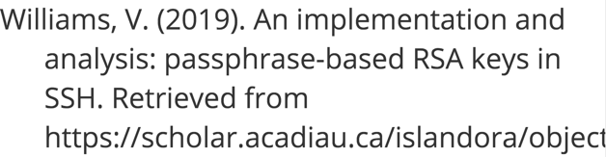

There was an issue noted with the ‘Choose the citation style’ box at 400% magnification. First, the box follows the scroll from the top of the page. This is confusing, when it starts at the top of the page. This positioning should be fixed, so it is only next to the actual drop down. As well, the box itself cannot be accessed without scrolling to the right at 400% magnification. Only a small sliver of black is seen, and could easily be missed.

 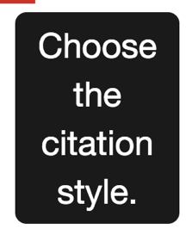

This off screen position also occurred next to the Style drop down. The box should be moved, so it can be accessed by everyone, only next to this drop down area.

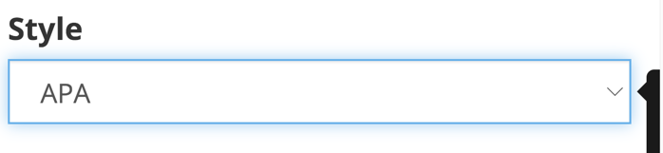

See the two hamburger menu issues noted at 400% (1440 x 900 resolution).One is the menu drop down not being easy to close, which is found in the Acadia Scholar Landing section. The other is the placement of the menu icon noted in the Acadia Scholar Profiles section.

**Acadia Scholar Advanced Search **PRIORITY\*\***

One minor issue was noted in the navigation when at 400% magnification. While the choices are readable, it is recommended this be shifted so that the ‘next’ is in a better position.

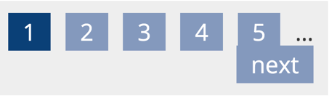

See the two hamburger menu issues noted at 400% (1440 x 900 resolution).One is the menu drop down not being easy to close, which is found in the Acadia Scholar Landing section. The other is the placement of the menu icon noted in the Acadia Scholar Profiles section.

**Chipman's Corner Digital Collection **PRIORITY\*\***

There was a majorly problematic issue found on this page, when at 400% magnification. All the items in each row are not all shown on screen, and there is no scrolling to the right possible to see the ones off screen. This **MUST** be remediated as soon as possible, as this page is not usable for many users.

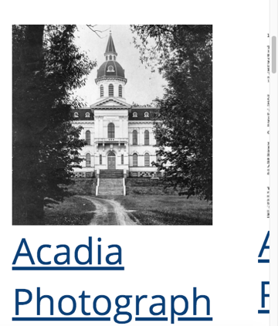 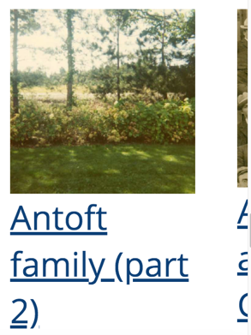

See the two hamburger menu issues noted at 400% (1440 x 900 resolution).One is the menu drop down not being easy to close, which is found in the Acadia Scholar Landing section. The other is the placement of the menu icon noted in the Acadia Scholar Profiles section.

**Chipman's Corner Image Record **PRIORITY\*\***

There was a majorly problematic issue found on this page, when at 200% and 400% magnification. All the words in the main title could not be seen on the screen, and there was no way of scrolling to the right to see them. This **MUST** be remediated as soon as possible, as this page is not usable for many users.

200%



400%



See the two hamburger menu issues noted at 400% (1440 x 900 resolution).One is the menu drop down not being easy to close, which is found in the Acadia Scholar Landing section. The other is the placement of the menu icon noted in the Acadia Scholar Profiles section.

**Chipman's Corner Document Record **PRIORITY\*\***

See the two hamburger menu issues noted at 400% (1440 x 900 resolution).One is the menu drop down not being easy to close, which is found in the Acadia Scholar Landing section. The other is the placement of the menu icon noted in the Acadia Scholar Profiles section.

**Acadia Library Home **PRIORITY\*\***

There are major issues noted with the page layout at 400% browser magnification. First, in the top menu bar, it scrolls significantly, and this **MUST** be remediated. All users should be able to access the entire page, without any scrolling. Second, all other content is needing to be scrolled, so the entire page needs to be recoded, so it is responsive.

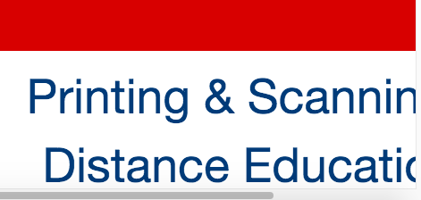

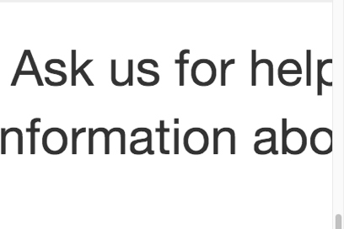

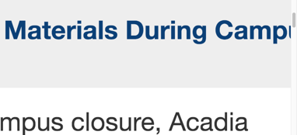

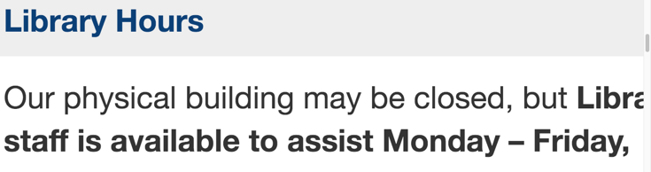

**Acadia Search **PRIORITY\*\***

See the 400% scrolling issue noted in Acadia Library Home.

**Acadia Library Hours **PRIORITY\*\***

See the 400% scrolling issue noted in Acadia Library Home.

**Acadia Loan Periods **PRIORITY\*\***

See the 400% scrolling issue noted in Acadia Library Home.

**Acadia Interlibrary Loans **PRIORITY\*\***

There was one minor issue noted at 200%, which may cause confusion for users with low vision. There is a split between the icon and link for Institutions. This is not a major issue, but if the icon and text link can be put on a separate line it would solve the issue on any magnified screen.



See the 400% scrolling issue noted in Acadia Library Home.

**Acadia What's Happening **PRIORITY\*\***

There was one issue noted at 200%. When the screen size is magnified in the browser the Twitter widget becomes the first thing that users access. In the code, this should be moved to the bottom, so that the important information on the page comes first, and then the Twitter widget comes last. Note this also is happening on the **VERY** important COVID-19 page.

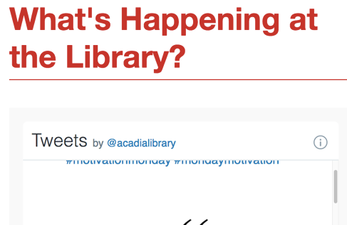

See the 400% scrolling issue noted in Acadia Library Home.

**Acadia Feedback (Contact Us) **PRIORITY\*\***

See the 400% scrolling issue noted in Acadia Library Home.

**Acadia Our People **PRIORITY\*\***

See the 400% scrolling issue noted in Acadia Library Home.

**Acadia Finding Things (Locations) **PRIORITY\*\***

There was one issue noted at both 200% and 400%. In the General Library Collections table, content goes off screen and it can’t be accessed, as there is no scroll. This table **MUST** be remediated, so that it is responsive to screen size.

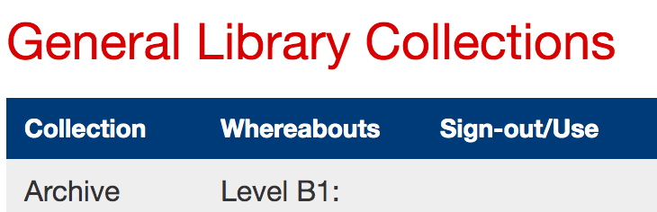

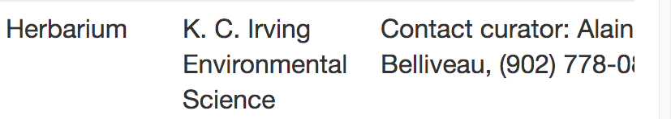

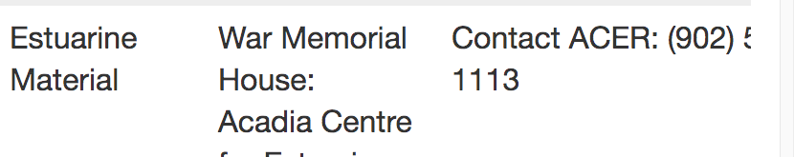

See the 400% scrolling issue noted in Acadia Library Home.

#### Small Screens

##### Importance and Users Impacted

Websites should be viewable and usable to users who view it on mobile phones (be responsive). WCAG 2.1 requires us to check the web sites on a small screen size of 320 pixels wide, so that no side scrolling is noted, and all elements and content are usable and accessible. This is the equivalent of an iPhone 5 screen at 320 x 568 Portrait. As well, web pages should be accessible to everyone, whether users employ portrait or landscape mode, or they switch between the two modes. This is important for people who have low vision, and/or physical disabilities, and/or cognitive disabilities.

##### Findings

**Acadia Scholar Landing** **\*\*PRIORITY\*\***

The menu drop down issue noted in the Magnification section, under Acadia Scholar Landing, also occurs on mobile. As well, the menu icon placement noted in the Magnification section, under Acadia Scholar Profiles, also occurs on mobile in portrait mode.

**Acadia Scholar Profiles **PRIORITY\*\***

The menu drop down issue noted in the Magnification section, under Acadia Scholar Landing, also occurs on mobile. The menu icon placement noted in the Magnification section, under Acadia Scholar Profiles, also occurs on mobile in portrait mode. As well, the major text overlapping noted in the Magnification section, under Acadia Scholar Profiles, also occurs in both landscape and portrait modes on mobile.

**Acadia Scholar Theses Search Results **PRIORITY\*\***

The menu drop down issue noted in the Magnification section also occurs on mobile. The menu icon placement noted in the Magnification section also occurs on mobile in portrait mode.

**Acadia Scholar Help **PRIORITY\*\***

The menu drop down issue noted in the Magnification section also occurs on mobile. The menu icon placement noted in the Magnification section also occurs on mobile in portrait mode.

**Acadia Scholar Contact **PRIORITY\*\***

The menu drop down issue noted in the Magnification section also occurs on mobile. The menu icon placement noted in the Magnification section also occurs on mobile in portrait mode.

**Acadia Scholar Thesis Example **PRIORITY\*\***

The citation style box placement issue noted in the Magnification Section, under Acadia Scholar Theses, is present in portrait mode on mobile. As well, in landscape mode, the box moves to a different place, as shown in the screen print below. This needs to be remediated, so the box is only next to the style drop down.

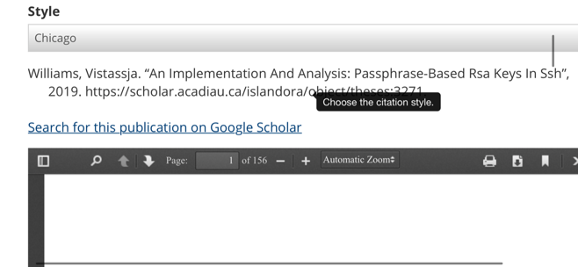

The menu drop down issue noted in the Magnification section also occurs on mobile. The menu icon placement noted in the Magnification section also occurs on mobile in portrait mode.

**Acadia Scholar Advanced Search **PRIORITY\*\***

The menu drop down issue noted in the Magnification section also occurs on mobile. The menu icon placement noted in the Magnification section also occurs on mobile in portrait mode.

**Chipman's Corner Digital Collection **PRIORITY\*\***

The major issue of not all items appearing on screen, with no scrolling possible, noted in the Magnification section, is also noted on mobile in profile mode. As well, the menu drop down issue noted in the Magnification section also occurs on mobile. The menu icon placement noted in the Magnification section also occurs on mobile in portrait mode.

**Chipman's Corner Image Record **PRIORITY\*\***

The same title cut off issue noted in the Magnification section is found on mobile in portrait and landscape modes. As well, the menu drop down issue noted in the Magnification section also occurs on mobile. The menu icon placement noted in the Magnification section also occurs on mobile in portrait mode.

**Chipman's Corner Document Record **PRIORITY\*\***

The menu drop down issue noted in the Magnification section also occurs on mobile. The menu icon placement noted in the Magnification section also occurs on mobile in portrait mode.

**Acadia Library Home **PRIORITY\*\***

There were significant layout issues noted on the small screen. The web pages must be recoded, so they are responsive for any layout.

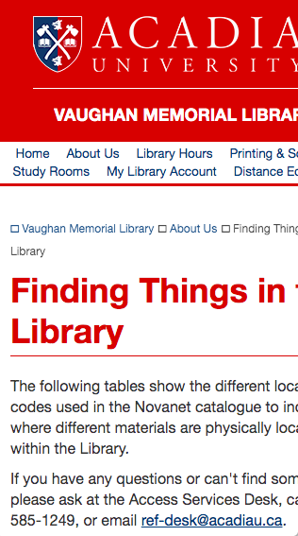



**Acadia Search **PRIORITY\*\***

See Acadia Library Home for the significant small screen issue.

**Acadia Library Hours **PRIORITY\*\***

See Acadia Library Home for the significant small screen issue.

**Acadia Loan Periods **PRIORITY\*\***

See Acadia Library Home for the significant small screen issue.

**Acadia Interlibrary Loans **PRIORITY\*\***

See Acadia Library Home for the significant small screen issue.

**Acadia What's Happening **PRIORITY\*\***

See Acadia Library Home for the significant small screen issue.

**Acadia Feedback (Contact Us) **PRIORITY\*\***

See Acadia Library Home for the significant small screen issue.

**Acadia Our People **PRIORITY\*\***

See Acadia Library Home for the significant small screen issue.

**Acadia Finding Things (Locations) **PRIORITY\*\***

See Acadia Library Home for the significant small screen issue.

#### Skip Links

##### Importance and Users Impacted

Best practice for web pages is for at least one ‘skip to’ link to be present at the top of each web page. This is used primarily, but not exclusively, by screen reader users who are blind, Deaf-Blind or have low vision, as well as people with sight, who use keyboard navigation. It gives these users a quick way to navigate the page from the top to the main content area, skipping repeated navigation, banner, etc. areas.

##### Findings

**Acadia Scholar Landing**

No issues noted.

**Acadia Scholar Profiles**

No issues noted.

**Acadia Scholar Theses Search Results**

No issues noted.

**Acadia Scholar Help**

No issues noted.

**Acadia Scholar Contact**

No issues noted.

**Acadia Scholar Thesis Example**

No issues noted.

**Acadia Scholar Advanced Search**

No issues noted.

**Chipman's Corner Digital Collection**

No issues noted.

**Chipman's Corner Image Record**

No issues noted.

**Chipman's Corner Document Record**

No issues noted.

**Acadia Library Home **PRIORITY\*\***

There is one skip link present, but it is invisible, even when tabbed. This should be made visible, when it is tabbed so that all users, including those with sight, can access it successfully and without confusion.

Another skip link should be added to go to the navigation area. Note that currently, when a user uses the tab key to navigate through the page, the side navigation is only available after the 48th tab click. This second skip link is crucial in this page layout.

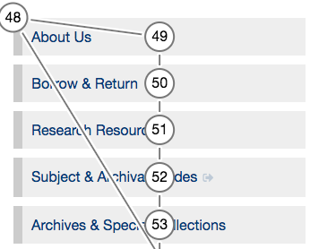

**Acadia Search **PRIORITY\*\***

See Acadia Library Home for the skip link issues.

**Acadia Library Hours **PRIORITY\*\***

See Acadia Library Home for the skip link issues.

**Acadia Loan Periods **PRIORITY\*\***

See Acadia Library Home for the skip link issues.

**Acadia Interlibrary Loans **PRIORITY\*\***

See Acadia Library Home for the skip link issues.

**Acadia What's Happening **PRIORITY\*\***

See Acadia Library Home for the skip link issues.

**Acadia Feedback (Contact Us) **PRIORITY\*\***

See Acadia Library Home for the skip link issues.

**Acadia Our People **PRIORITY\*\***

See Acadia Library Home for the skip link issues.

**Acadia Finding Things (Locations) **PRIORITY\*\***

See Acadia Library Home for the skip link issues.

#### Keyboard and Focus

##### Importance and Users Impacted

Some users may use a keyboard, but not a mouse, on a traditional computer, device and/or smartphone for navigation. These users may use the tab key, enter key, spacebar and arrow keys to navigate the page content. These keyboard users should be able to tab through links, buttons, form elements, menu items, etc. from top to bottom, following the visual order that sighted users would access.

Many people can use keyboard only navigation, including screen reader users who are blind, Deaf-Blind or low vision, and/or people with physical disabilities, and/or people who use voice recognition software. These users may rely on tabbing (or similar with voice recognition) on each link and form element for navigation through a web page.

As well, we need to ensure that all links, form elements, buttons, etc. have very good visible focus, where a coloured line or box is highlighting the tab focus (colour depends on the background colour-see the Colour Contrast and Combinations Section) through the :focus selector in the css file. This is crucial for sighted users who use keyboard only navigation, as they count on it to see where they are in the page.

Currently, some browsers show this focus automatically without code being present. However, this code should be in the css file for every link, button, form element, etc. This will ensure that different browsers show the focus in a similar way, and all users can easily and quickly access content.

The new WCAG 2.2 requirement in 2.4.11 has been thought to mean (it just came out March 2020) that there needs to be a minimum focus line thickness of 2 CSS pixels, and the colour needs to be checked towards the colour ratio, mentioned in the Colour Section.

##### Findings

**Acadia Scholar Landing **PRIORITY\*\***

On Chrome (Mac), the search input area did not have a focus indictor, and this needs to be added in the CSS file.



In all pages, the top search bar is also missing the focus indicator, when tested in Chrome (Mac). This also needs to be added in the CSS file.



When testing was done in Firefox (Mac), very few links had focus applied to them. Only the search bar area had visible focus. This was odd behaviour, and the CSS file should be checked to ensure all links and form input areas have focus applied to them. As well, ensure that all have a minimum of 2 pixel width for that focus (3 pixels is recommended for this site).

The CSS should be checked, so that all links and form elements have a focus state specifically applied (such as a: focus).

**Acadia Scholar Profiles **PRIORITY\*\***

See the notes about the missing focus in the top search bar input area, CSS focus code and the Firefox focus issue in the Acadia Scholar Landing area.

**Acadia Scholar Theses Search Results **PRIORITY\*\***

See the issue noted with the function bar in the Chipman's Corner Digital Collection area, As well, see the notes about the missing focus in the top search bar input area, CSS focus code and the Firefox focus issue in the Acadia Scholar Landing area.

**Acadia Scholar Help **PRIORITY\*\***

See the notes about the missing focus in the top search bar input area, CSS focus code and the Firefox focus issue in the Acadia Scholar Landing area.

**Acadia Scholar Contact **PRIORITY\*\***

See the notes about the missing focus in the top search bar input area, CSS focus code and the Firefox focus issue in the Acadia Scholar Landing area.

**Acadia Scholar Thesis Example **PRIORITY\*\***

See the notes about the missing focus in the top search bar input area, CSS focus code and the Firefox focus issue in the Acadia Scholar Landing area.

**Acadia Scholar Advanced Search **PRIORITY\*\***

See the notes about the missing focus in the top search bar input area, CSS focus code and the Firefox focus issue in the Acadia Scholar Landing area.

**Chipman's Corner Digital Collection **PRIORITY\*\***

Focus is applied to the page number links. However, the colour is very hard to see, and should be checked for the WCAG ratio.

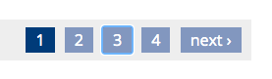

See the notes about the missing focus in the top search bar input area, CSS focus code and the Firefox focus issue in the Acadia Scholar Landing area.

**Chipman's Corner Image Record **PRIORITY\*\***

See the notes about the missing focus in the top search bar input area, CSS focus code and the Firefox focus issue in the Acadia Scholar Landing area.

**Chipman's Corner Document Record **PRIORITY\*\***

Focus was applied for the function items in the viewer bar, as shown below. However, this focus is almost impossible to see and must be changed so that all viewers can access it.



See the notes about the missing focus in the top search bar input area, CSS focus code and the Firefox focus issue in the Acadia Scholar Landing area.

One other related noted. The tester with ADHD noted problems with the bookmark feature. This should be investigated further:

“I can’t get it to work I did find the book mark selection below the document when I was looking for properties, but I cant get the bookmark to do anything on the document – the icon in the upper right.”

The tester also related more about the bookmarking feature, and then the associated bookmarked items page. This page should be investigated:

“I don’t understand the export options- does this require a sign in? also not sure what the purpose of bookmarking it is – and if there is a difference between the book mark bar on the bottom of the document and the book mark icon in the top right of the document…[Also] include in the navigation tool help to make this user friendly, how to use the tools on the document and why to use them.”

Issues with the bookmarking page were also noted by the tester with mobility and migraine disabilities, who uses text to speech software to navigate pages. These issues **MUST** be remediated as they could not access these features. They noted:

“…the “Export” button could not be read by my software. So again, if only relying on my software, I would not be able to export it…my software could not read the “remove” button. So again, if only relying on my software, I would not be able to remove it.”

The tester with hearing and visual disabilities, who used two different screen readers also noted **major** access issues with the Export and remove features. Again, as noted before the aria hidden code is present, and is likely causing these issues. This code **MUST** be removed, and testing redone.

“JAWS: its on my list but I do not have the option to export it.  
VO: No I cant.”

“[in relation to exporting and removing the bookmark]…

JAWS: I could not do all of these. The option to do these was not found by tabbing or read to me.

VO: I could not do all of these, he options were not read to me.”

Note that aria-hidden="true" was used in the Export and Remove buttons, and it is surmised that this is causing the issue. It should be removed, and retested to ensure that is causing the problem.

**Acadia Library Home **PRIORITY\*\***

Focus was applied to all links by the browser. However, the CSS needs to be changed so that all links and form elements have a focus state specifically applied (such as a: focus)

**Acadia Search **PRIORITY\*\***

See note in Acadia Library Home on CSS focus state needing to be added.

**Acadia Library Hours **PRIORITY\*\***

See note in Acadia Library Home on CSS focus state needing to be added.

**Acadia Loan Periods **PRIORITY\*\***

See note in Acadia Library Home on CSS focus state needing to be added.

**Acadia Interlibrary Loans **PRIORITY\*\***

See note in Acadia Library Home on CSS focus state needing to be added.

**Acadia What's Happening **PRIORITY\*\***

There is an issue on this page with the keyboard focus that **MUST** be remediated. If a user tabs through this page, right after the breadcrumb area, the user is then directed to the Twitter widget and must do many tabs to get through each post, and then they can go back to the main content of the page. This **MUST** be changed so that the user tabs through the important content, page numbers and then the Twitter widget.

See note in Acadia Library Home on CSS focus state needing to be added.

**Acadia Feedback (Contact Us) **PRIORITY\*\***

See note in Acadia Library Home on CSS focus state needing to be added.

**Acadia Our People **PRIORITY\*\***

See note in Acadia Library Home on CSS focus state needing to be added.

**Acadia Finding Things (Locations) **PRIORITY\*\***

See note in Acadia Library Home on CSS focus state needing to be added.

#### Colour

##### Importance and Users Impacted

The colour combinations used in text and background, both on images and text, need to pass the WCAG 2.1 Level AA colour contrast ratios (in this case the ratio of 4.5:1 for regular text). This will help make the text easier to read for the majority of users, including elders and people with visual disabilities, such as low vision, and/or cognitive, neurological, intellectual and/or learning disabilities.

There are many checkers to help with this, including the online WebAIM Color Contrast Checker (<https://webaim.org/resources/contrastchecker/>), and the downloadable Colour Contrast Analyser (<https://developer.paciellogroup.com/resources/contrastanalyser/>). Note that all colour combinations should be rechecked, including all states of links, buttons, images, etc.

As well, colour combinations need to be checked for colour blindness issues. Some colour combinations for text and background, such as red/green, blue/yellow, etc. can be problematic for these users.

##### Findings

**Acadia Scholar Landing SECONDARY PRIORITY\***

There were two areas that need to be remediated on this page. First, the top red and yellow area and the Search button, use yellow and blue for the ‘button’ links. This may be problematic for some people with severe blue/yellow colour blindness, so this combination should be reconsidered.



As well, the text that surrounds the search area, including ‘Advanced Search’, should be remediated, because it isn’t currently passing the WCAG ratio.



The tester with mobility and migraine disabilities noted that the Advanced Search text is hard to read, and they did not have stated visual disabilities:

“Advanced search” is difficult to read when the background is white.”

Finally, there are many colours used on this page. It is highly recommended that this be reconsidered, as they could make it hard for some users to focus and concentrate.

**Acadia Scholar Profiles**

No issues noted.

**Acadia Scholar Theses Search Results SECONDARY PRIORITY\***

There were two areas that did not pass the WCAG ratio, and those were the top and bottom number link areas. The blue background should be changed.



As well, the peach colour in the graph, and the grey colour used in the arrows, both don’t pass the WCAG ratio. These need to be changed to stronger colours, so they pass the contrast ratio.

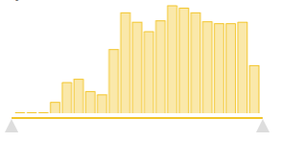

**Acadia Scholar Help**

No issues noted.

**Acadia Scholar Contact**

No issues noted.

**Acadia Scholar Thesis Example**

No issues noted.

**Acadia Scholar Advanced Search**

No issues noted.

**Chipman's Corner Digital Collection SECONDARY PRIORITY\***

There was one area that did not pass the WCAG ratio, and that was the bottom number link area. The blue background should be changed.



**Chipman's Corner Image Record**

No issues noted.

**Chipman's Corner Document Record**

No issues noted.

**Acadia Library Home**

No issues noted.

**Acadia Search **PRIORITY\*\***

There were numerous colour issues noted on this page. The grey colour used for ‘Type’, ‘Versions”, ‘Details’, ‘Author’, etc. needs to be made darker for more contrast. Examples of the grey areas are shown in the screen prints below.

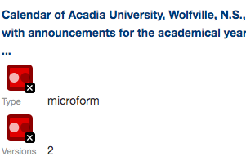

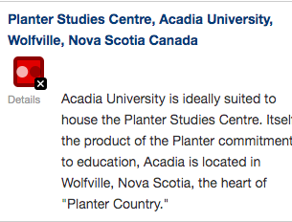

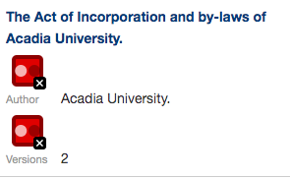

One minor colour note on this page. The small text beneath the search may be very hard to read by many users. It is recommended the background be blocked by about 25% more to get more readable for users.

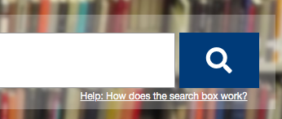

**Acadia Library Hours**

No issues noted.

**Acadia Loan Periods**

No issues noted.

**Acadia Interlibrary Loans**

No issues noted.

**Acadia What's Happening**

No issues noted.

**Acadia Feedback (Contact Us)**

No issues noted.

**Acadia Our People**

No issues noted.

**Acadia Finding Things (Locations)**

No issues noted.

#### Links

##### Importance and Users Impacted

Text links need to be descriptive to tell all users, including those with limited or no sight and those with cognitive disabilities, what they are, and where the user will go when activated. Text links should also follow best practice of being underlined, being in a different colour than the text (with strong contrast) and each being unique, not generic such as ‘Click here’. Images, with or without text, can also be linked. Those will be covered in the Images Section.

In the rare cases where links can’t be given descriptive text (and this should be done with extreme caution), then at a minimum an aria-label can be applied to the code to provide that description (example, aria-label="Description of link."). This code can be problematic for screen readers, and/or voice recognition software.

##### Findings

**Acadia Scholar Landing**

No issues noted.

**Acadia Scholar Profiles**

No issues noted.

**Acadia Scholar Theses Search Results**

No issues noted.

**Acadia Scholar Help**

No issues noted.

**Acadia Scholar Contact**

No issues noted.

**Acadia Scholar Thesis Example**

No issues noted.

**Acadia Scholar Advanced Search**

No issues noted.

**Chipman's Corner Digital Collection **PRIORITY\*\***

The tester with hearing and visual disabilities, who used two different screen readers was asked to go to a specific collection. They went to the Chipman Family on page 2 and then found repetitive link information.

“JAWS: I found the results fine. At first, It was ok and I understood the results but then when it got to the “Copy letter Sir Charles Topper: I heard the link repeatedly like give times. Then I heard “Correspondence” link like five times. I don’t know what the difference is between each occurrence because the difference was not stated to me.   
  
Also, I don’t know what the collection is about. Is it music? Are they letters? It will be good to have a short description of what the collection is and what each item is and the years they wer created.

“VO: Same experience- repetition and lack of clarity.”

The tester noted multiple different occurrences of the same phrase. This is due to the fact that there are two links, one is the image (left) and the second one the text link (right). Then there are two titles. Most screen reader users cannot access the titles, but in this case, they were accessed by the user. The titles should be deleted on all images and links, as they are not used by the majority of viewers, and should only be used in rare circumstances.

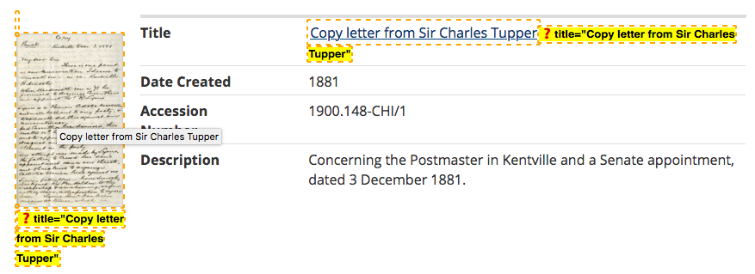 **Chipman's Corner Image Record**

No issues noted.

**Chipman's Corner Document Record**

No issues noted.

**Acadia Library Home **PRIORITY\*\***

The consent window has a compliance agreement button. If the user clicks on it, or not, the website still works for them. Technically this is not a link, but a button. It has been given an ARIA role of button, but it is highly recommended that the link code below be changed to a <button>. Voice control users on iPhone can’t activate the button, so the pop up can’t be closed. This **MUST** be remediated.

<div class="cc-compliance">  
<a aria-label="dismiss cookie message" role="button" tabindex="0" class="cc-btn cc-dismiss">  
I understand  
</a>  
</div>

**Acadia Search **PRIORITY\*\***

See button issue noted in the Acadia Library Home section.

**Acadia Library Hours **PRIORITY\*\***

See button issue noted in the Acadia Library Home section.

**Acadia Loan Periods **PRIORITY\*\***

See button issue noted in the Acadia Library Home section.

**Acadia Interlibrary Loans **PRIORITY\*\***

See button issue noted in the Acadia Library Home section.

**Acadia What's Happening **PRIORITY\*\***

There was an issue noted on this page. The generic ‘Read more’ phrase was used for each item in the main content area. The main title is linked, and it is descriptive. To increase the usability of the page by people without sight, if possible, the ‘Read more’ link should be removed, because they are not required.

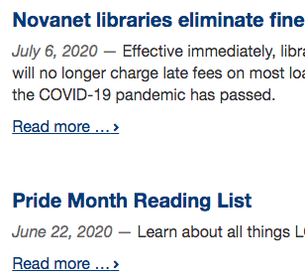

**Acadia Feedback (Contact Us) **PRIORITY\*\***

See button issue noted in the Acadia Library Home section.

**Acadia Our People **PRIORITY\*\***

See button issue noted in the Acadia Library Home section.

**Acadia Finding Things (Locations) **PRIORITY\*\***

See button issue noted in the Acadia Library Home section.

#### Font Type, Size and Styling

##### Importance and Users Impacted

Best practice is to use sans-serif font types, and a font size 12 point or above. All CSS files should be double checked to ensure that pixels (px) is not being used for text. Font sizes should be at a minimum of 100% or 1.0 em (or rem). As well, italics and bold should be used sparingly, again following best practice.

This will help make the text easier to read for the majority of users, including elders and people with visual disabilities, such as low vision, and/or cognitive, neurological, intellectual and/or learning disabilities.

##### Findings

**Acadia Scholar Landing**

No issues noted.

**Acadia Scholar Profiles**

No issues noted.

**Acadia Scholar Theses Search Results**

No issues noted.

**Acadia Scholar Help**

No issues noted.

**Acadia Scholar Contact**

No issues noted.

**Acadia Scholar Thesis Example**

No issues noted.

**Acadia Scholar Advanced Search**

No issues noted.

**Chipman's Corner Digital Collection**

This isn’t a font, size or styling issue per se, but involves content. One important note from this tester involved the use of handwritten scanned documents. This is a **VERY** important recommendation:

“For student with visual impairments, it would be good if there was a statement such as, “The items in this document are handwritten and are not screen reader accessible” and maybe offer an alternative resource to finding an accessible version of the contents.”

The tester with low vision noted one important recommendation for the Chipman’s Corner Digital Collection list of archival materials on that main page:

“The layout of the general collections page generally made sense, although I don’t understand the images with the hyperlinks below them. What is “Acacia Villa School”? I’m unsure as to whether that’s a collection of photos on the school, or what it is. It might be helpful to have descriptions.”  
  
“Overall, this page is well designed and laid out. Brief descriptions of each item might be valuable as it can be confusing to see all those images with random names, especially when magnified.”

**Chipman's Corner Image Record**

No issues noted.

**Chipman's Corner Document Record**

No issues noted.

**Acadia Library Home**

No issues noted.

**Acadia Search**

No issues noted.

**Acadia Library Hours**

There was small text in italics noted in one area, as shown in the screen print below. Text size should be 100%, or the equivalent, and all italics should be removed.

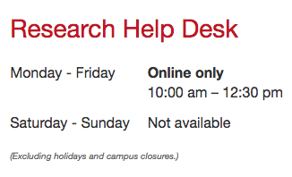

**Acadia Loan Periods **PRIORITY\*\***

There were a few instances of very small text and italics used on this page. One example is shown below. All of these areas must be remediated. Text size should be 100%, or the equivalent, and all italics should be removed. This will make these areas accessible for everyone, including people with cognitive disabilities, and/or visual disabilities.

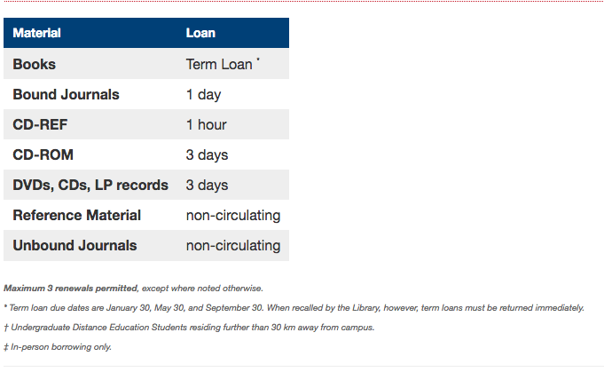

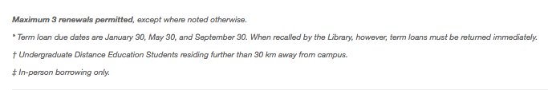

**Acadia Interlibrary Loans **PRIORITY\*\***

There is one issue that was found. There is underline used on this page in three areas. One example is noted below. Underline should be avoided, as it is confused for a link. The underlining should be removed. If emphasis is needed, then bold should be used.

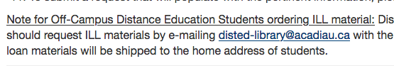

**Acadia What's Happening**

On the Acadia Library What’s Happening? Page, the tester with low vision noted that the page numbers at the bottom were very small, and should use a larger font size.

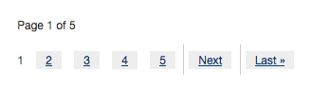

**Acadia Feedback (Contact Us)**

No issues noted.

**Acadia Our People**

No issues noted.

**Acadia Finding Things (Locations)**

No issues noted.

#### Navigation & Drop Down Menus

##### Importance and Users Impacted

The website should be as easy as possible to navigate for all users. The navigation should be consistent throughout the site, not only in placement, but also in the text used to describe each link. The navigation should also ideally show viewers where they are in the site hierarchy in some way. The way the navigation structures are coded is also important, as it needs to ensure that users can access the navigation, whether they are using different technology or not.

Drop down menus should be easy to use, and accessible to all users, including those who use different technologies.

##### Findings

**Acadia Scholar Landing **PRIORITY\*\***

There was an issue noted by the tester with mobility and migraine disabilities, who uses text to speech software to navigate pages. Under the browse collections area, their software could not access the link ‘Student projects’:

“When using Speech to Text chrome extension, I highlighted “Student projects” and it was unable to read it. That’s an issue. It only read “Acadia Scholar, Browse Collections” meaning the search and advanced search were also omitted and thus, not accessible.”

One other note, was from the sighted tester with ADHD, who didn’t use software. They noted that the layout and navigation was well done:

“Love the lay out first glance. I have never seen a site like this (content wise) - right away it discloses the mission or goal of the project and whose project it is with a clever use of hyper links to redirect externally rather than clutter a page.”

**Acadia Scholar Profiles**

No issues noted.

**Acadia Scholar Theses Search Results**

No issues noted.

**Acadia Scholar Help**

No issues noted.

**Acadia Scholar Contact**

No issues noted.

**Acadia Scholar Thesis Example **PRIORITY\*\***

No issues noted specifically with navigation and drop downs, However, there was an associated issue that must be remediated.

The citation style area did pose challenges for the tester with mobility and migraine disabilities, who uses text to speech software to navigate pages. They could not access the different styles, using their software.

“I can choose it [Chicago] and it worked as the citation changed in real time. However, my software can’t read “Style” hence if I was only relying on my software, I would be unable to even know where to find citation styles. Obviously, it’s a dropdown bar, so it was unable to read the different types of citations (APA, Chicago, etc).”

This issue **MUST** be remediated so that all users can access this style changer. The code was examined, and no recommendation could be provided at this time. The <label> and <select> were connected by the ‘for’ and ‘name’, the <select> has a name and options all have values. The issue could not be noted at this time. It is possible that this is a software bug.

The tester with hearing and visual disabilities, who used two different screen readers could access the style changer with JAWS and VoiceOver screen readers. However, with VoiceOver on iPhone they didn’t know that the selection made changes. This likely could be fixed by adding ARIA to this functionality to alert on changes.

“JAWS: Yes, it worked. Jaws made a sound. I Alt+Tabb’d back and it was there.

VO:Yes, it worked but VO didn’t make any sound and there was no way to know that my selection made any changes.”

The tester with hearing and visual disabilities, who used two different screen readers also noted quite a few issues that related to the Acrobat in page viewer. They could print the document, and download the document, but other functions were problematic. Here are the major issues related to the Adobe viewer:

“JAWS: I was able to go to page 50. It read to me as Chapter 5. Even though it read the appreciation page before doing so- this was quite confusing. Page navigation is tricky. To change pages, I had to go to the spin box at the top to type in the numbers. There should be an easier way to navigate through the pages and the instruction should be read at the top of the page. Like “Press Shift+ right arrow to go to the next page”.

“VO :First, the stepper wasn’t working. VO told me to press ctrl+Option+Shift+Down arrow to activate it but it didmt work. Then when I typed in 5-0, I tabbed down to the page to read it and it read “Link Viewer. Html”. I clicked on this link and… nothing. I couldn’t read the page.”

“JAWS: I went to the Tools tab, scrolled to the end, then pressed Tab. I went through this procedure twice to make sure it wasn’t just sheer luck I found it. I think the bookmark section should be clearly stated a s Bookmarks. It really took me some thought to figure out where it could be.”

“JAWS: this [Zoom] function is very annoying because after you zoom in once, you have to go all the way to the top and tab back again to zoom in twice. This is very frustrating. I have no time for this. I zoomed in twice and that’s it. I definitely couldn’t zoom in as many times I would have needed to because of how it works. I assume its working. I can’t see enough to know if it actually zoomed in for sure.  
VO: Yes, it worked fine. I would have liked it to say “press down arrow” to choose size” for clarity rather than using my brain to figure it out.”

“JAWS: During the page navigation, I found myself stuck in the document and it would read “Same page information” or so.   
VO: I found myself stuck and unable to navigate the page a lot as well. I think there is something wrong with the way the thesis is being displayed.”

For this last access issue, it is not known what was causing this barrier. A second test would need to be done without the Acrobat widget on the page.

The tester with low vision noted colour issues with the Acrobat built in viewer, and issues relating to their use of Zoom on iPad. This zoom issue is likely related to the built-in viewer.

“This was a fairly easy [search] process and I was able to understand it well, although I struggle a bit with the dark grey text box next to the black document header. It was challenging to zoom into that as the webpage or document kept trying to move rather than pinch to zoom…I struggled whenever I tried to pinch to zoom, as it kept on trying to scroll the page or the screen.”

This tester also noted other issues with the Acrobat built in viewer:

“I could not download the document. When I hit the download button, the screens changed and the document bar disappeared, but the document didn’t download.”

The Acrobat viewer is a third party widget. Users may have to download the thesis, and use it on their own computer, until Adobe improves the web page viewer. Thus, it may be possible to add text and a text link at the top of the page, noting that the PDF can be downloaded. This may provide a suitable option for users, who encounter barriers with the PDF widget.

**Acadia Scholar Advanced Search**

No issues noted.

**Chipman's Corner Digital Collection**

No issues noted.

**Chipman's Corner Image Record **PRIORITY\*\***

No issues noted on the overall navigation. The tester with hearing and mobility disabilities noted that the size of the buttons used to zoom, full screen and home were too small. These are shown in the screen print below. It is **HIGHLY** recommended that these should be increased in size, so all users can access them without difficulty.

“I recommend increasing the size of the buttons as they are hard to distinguish and see. The buttons require more eye strain to notice the buttons.”



The tester with hearing and visual disabilities, who used two different screen readers noted a **MAJOR** accessibility issue. Screen reader users can only access part of this page, until the image viewer. **They CAN’T access the text description area. This is a major issue and MUST be remediated ASAP.** The code must be changed, so that this area can be accessed.

“VO: the options were not tabbable. It was a bluenose flying train… I think that’s what I heard in the description. Anyway, I couldn’t get to the lower part of the page that had all the written descriptions. When I used my down arrow, it still didn’t read anything to me.”

“JAWS: First, let me say that the options are not tabbable. I had to find an alternative route mid-way into doing the test by down arrowing. This is not ideal. Iotions should be tabbable. When I used the down arrow, I was able to find the out that it’s a Postcard of Anapolis valley. The picture description, I think was well-detailed so that workd well…. I believe.

VO: It needs to be tabbable. The description of the picture is good but everything else is unreadable to me.”

The zoom and button functionality on the left upper side is NOT accessible to screen reader users, because there was no way of knowing whether the zoom worked or not. ARIA code needs to be added to this functionality, and then retested.

“JAWS: No, this option is not tabbable. I used my down arrow and pressed enter on the option but I don’t know if it actually zoomed cos it doesn’t say anything.

VO: ano, this option was not read to me while tabbing and even when I down arrowed.”

They couldn’t toggle to full screen either:

“JAWS: No, it says it’s a graphic so I don’t even think it’s a working function. When I click on it, it doesn’t say its making a difference on my screen.  
VO: No.”

The tester with low vision noted two barriers when using the in page viewer. One involved the zoom, and the other involved the button colour contrast. Both should be remediated by the zoom maker.

“I struggled to zoom in and out of this image. I use pinch to zoom on the iPad and it regularly has issues with these zoom functions as the iPad can sometimes zoom when I actually want just the picture to zoom. It is challenging to reset the zoom to default when this happens. I didn’t like the document viewer as I find it difficult to zoom and it clashes with my devices zoom function.”

“I can toggle to the full screen and then back to the original screen size, although the button for the full screen is very small and difficult to see (grey isn’t a good colour for that).”

**Chipman's Corner Document Record**

No issues noted.

**Acadia Library Home **PRIORITY\*\***

On mobile, iPhone 11, the only navigation shown on Portrait mode and Landscape mode was the top navigation bar. The detailed navigation area needs to be added, as it is found on all other pages.

**Acadia Search **PRIORITY\*\***

On mobile, iPhone 11, the only navigation shown on Portrait mode and Landscape mode was the top navigation bar. The detailed navigation area needs to be added, as it is found on all other pages.

**Acadia Library Hours **PRIORITY\*\***

A major issue was noted for the navigation on this page. The navigation in Portrait mode on mobile (iPhone 11) was deemed problematic. The top navigation bar is usable and noticeable to the user.

The detailed navigation bar that is found on the left side, when on computer, is now only noted as a drop down at the bottom of the page. Responsive websites usually use a hamburger menu that can be dropped up and down, and this holds all navigation. This is recommended for these pages. As well, the current navigation bar can **NOT** be accessed by people who use voice control on iPhone. This **MUST** be remediated.

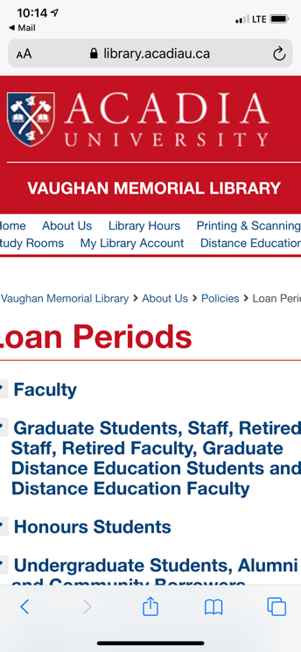 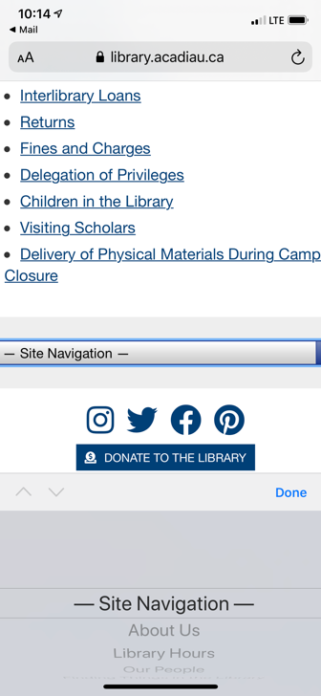

**Acadia Loan Periods **PRIORITY\*\***

There were issues noted in the code itself. The main ARIA parent role tablist is missing for each drop down section, and needs to be added, so the children can be nested underneath it.

See the major navigation issues noted in the Acadia Library Hours section, and the issues found in the Acadia Interlibrary Loans section.

**Acadia Interlibrary Loans **PRIORITY\*\***

There are major issues found on this page, in the drop down question’s areas. Voice control on iPhone 11 can’t access any of the drop downs. Sometimes one drop down will be accessed, quite by accident and not knowingly! These drop downs need to be recoded, so all users can access them.  
  
The tester with hearing and visual disabilities, who used two different screen readers **COULD NOT ACCESS** the drop downs used on this page. They must be changed so they can be accessed by everyone.

“JAWS: I can read the questions just fine but I cant read the answers. When it reads a tab, then it says “Tab collapsed”. I press enter then it says “Extended but doesn’t then reads another question. No answer.  
VO: Same experience. No answers just questions.”

This tester also had one more comment about this page:  
  
“Why do I have to go through so many links to get to the main content if that’s the content the page is for? I should be able to just get on the page and read the content I’m looking for without going through so many tabs to get there.”

On the Acadia Library Interlibrary Loans page, the tester with low vision noted that the answer drop downs only allowed one to be lowered at a time. This script should be reconsidered, as it may be ‘jarring’ for many users:

“This system of questions and answers worked well enough, however when I clicked on a question further down the page and had a question open further up, it would close the top question and open the one I had clicked. This would sometimes cause the question to open above the top of my screen, so I’d need to scroll back up a bit to find it. This was a bit disconcerting”  
  
“…would suggest not having the first question close if you then open a question further down the page as this can mess up navigation a bit when you’re zoomed in far enough”

The tester with low vision noted that it wasn’t immediately apparent that the indentation meant subcategories:

“I was able to click the links and they worked. It took me a moment or two to realise that the tabs that are slightly indented are subcategories (I.e Novanet is a subcategory for Borrow and Return). Perhaps increasing the indent would help make it clearer that those are subcategories.”

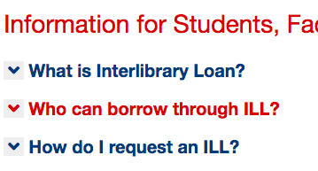

There were also issues noted in the code itself. The main ARIA parent role tablist is missing for each drop down section, and needs to be added, so the children can be nested underneath it.

The tester with mobility and migraine disabilities, who uses text to speech software to navigate pages, noted that the drop down arrow did not work with their software, so it wasn’t accessible:

“Yes my software was able to read the questions and the dropdown answers. Although the software cant read the dropdown arrow, so if only relying on the software, I would be able to click the arrow, and thus, receive the answers.”

They also noted something about the drop down mechanism, which is recommended to help all users:

“It would be more accessible if I could open more than one dropdown (answer) at one time. Especially if I wanted to compare answers or something.”

Plus, they added one note about using acronyms, such as ILL. This should be considered:

“Can ILL be defined in the title such as “Interlibrary Loans (ILL)” or “Request an Interlibrary Loan (ILL)” or put it just under the title? Especially if I don’t click the first dropdown menu where it is defined, I’m not 100% sure what ILL means, although I can guess from the page title?”

See the major navigation issues noted in the Acadia Library Hours section.

**Acadia What's Happening **PRIORITY\*\***

The tester with hearing and visual disabilities, who used two different screen readers found barriers when trying to access the page numbers at the bottom of the Acadia Library What’s Happening page. The code seems to be valid, but this should be investigated further.

“JAWS: First, it does not read any page numbers to me and as far as I scrolled, it does not say anything about COVID 19.   
VO: There were no page numbers.”

One note about the What’s Happening page by the tester with mobility and migraine disabilities, who uses text to speech software to navigate pages:

“And generally, this was the first test where my software was able to read everything! Very pleased with this! This is a pretty accessible page. Well done!”

See the major navigation issues noted in the Acadia Library Hours section.

**Acadia Feedback (Contact Us) **PRIORITY\*\***

See the major navigation issues noted in the Acadia Library Hours section.

**Acadia Our People **PRIORITY\*\***

See the major navigation issues noted in the Acadia Library Hours section.

**Acadia Finding Things (Locations) **PRIORITY\*\***

See the major navigation issues noted in the Acadia Library Hours section.

#### iFrame

##### Importance and Users Impacted

iFrames are a way to link to a web page, video, etc. inside a frame in another web page. These are required to have a title, to provide information about the content of the linked item, primarily for people who use screen readers.

##### Findings

**Acadia Scholar Landing**

No issues noted.

**Acadia Scholar Profiles**

No issues noted.

**Acadia Scholar Theses Search Results**

No issues noted.

**Acadia Scholar Help**

No issues noted.

**Acadia Scholar Contact**

No issues noted.

**Acadia Scholar Thesis Example **PRIORITY\*\***

One iFrame was noted and it needs a title added to the code. This must be remediated. See the example in Acadia Biology for how to fix this error.



**Acadia Scholar Advanced Search**

No issues noted.

**Chipman's Corner Digital Collection**

No issues noted.

**Chipman's Corner Image Record**

No issues noted.

**Chipman's Corner Document Record **PRIORITY\*\***

One iFrame was noted and it needs a title added to the code. This must be remediated. See the example in Acadia Biology for how to fix this error.

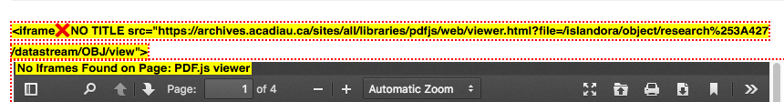

**Acadia Library Home**

No issues noted.

**Acadia Search**

No issues noted.

**Acadia Library Hours**

No issues noted.

**Acadia Loan Periods**

No issues noted.

**Acadia Interlibrary Loans**

No issues noted.

**Acadia What's Happening *SECONDARY PRIORITY\***

No issues noted with the iFrame present on the page. However, note that there are three iFrames present, when only one is being used. All three appear to be related to the Twitter widget. The two at the bottom of the page are not being used by users, thus their titles should be examined. Possibly, adding words such as ‘Twitter widget iframe, not important’ would be useful for non-sighted users, who use screen readers.

One item to note that relates to the Twitter widget, that may (or may not) involve the iFrane use. On the Acadia Library What’s Happening? Page, the tester with low vision noted one issue when they used pinch to zoom. Note that the vendor of this widget should be made aware of this issue.

“The one issue I found with this page was that when I was zoomed in and I looked at the recent tweets section it was challenging to navigate as trying to navigate up or down dragged the tweets up or down and not the whole screen, so I had to zoom out before I could navigate up or down.”

**Acadia Feedback (Contact Us) **PRIORITY\*\***

There was a n issue found with the Google Maps iFrame. It is missing a title, and this **MUST** be added to make it more accessible for people who use screen readers.

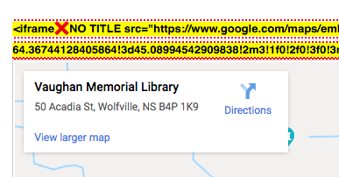

**Acadia Our People**

No issues noted.

**Acadia Finding Things (Locations)**

No issues noted.

#### Headings

##### Importance and Users Impacted

Headings on web pages should be styled differently from the main text content for sighted users, using bold, larger text sizes, etc. Headings also need to be noted in the HTML code, so that screen reader users who are blind, Deaf-Blind or have low vision, can also access them. These are crucial invisible signposts for these users, as they indicate the overall structure of the page, and give an idea of the overall page content as well.

Headings are given numbers to indicate their importance. A Heading 1 (<h1>) would indicate the main title on the web page, a Heading 2 (<h2>) would indicate a major section, etc. The numbers should be used in order, as this helps screen reader users better understand the overall structure of the page.

##### Findings

**Acadia Scholar Landing **PRIORITY\*\***

The headings on this page all need to be redone. The Heading 1 needs to be moved to the main title of the page, which is Acadia Scholar.



Then the sentences with the current Heading 1 and Heading 6, should be changed to a paragraph. These are not headings, but paragraphs.

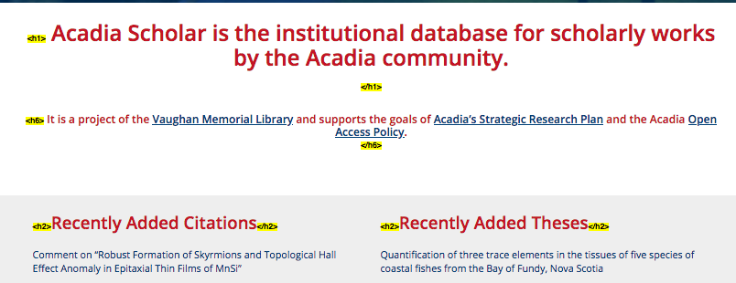

**Acadia Scholar Profiles **PRIORITY\*\***

At the top of the page, the Heading 1 surrounding the title of the section in the banner area needs to be removed. That will leave only one Heading 1 for the main title of the page.

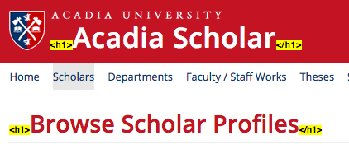

**Acadia Scholar Theses Search Results **PRIORITY\*\***

At the top of the page, the Heading 1 surrounding the title of the section in the banner area needs to be removed. That will leave only one Heading 1 for the main title of the page.

**Acadia Scholar Help **PRIORITY\*\***

At the top of the page, the Heading 1 surrounding the title of the section in the banner area needs to be removed. That will leave only one Heading 1 for the main title of the page.

**Acadia Scholar Contact **PRIORITY\*\***

At the top of the page, the Heading 1 surrounding the title of the section in the banner area needs to be removed. That will leave only one Heading 1 for the main title of the page.

**Acadia Scholar Thesis Example **PRIORITY\*\***

At the top of the page, the Heading 1 surrounding the title of the section in the banner area needs to be removed. That will leave only one Heading 1 for the main title of the page.

**Acadia Scholar Advanced Search **PRIORITY\*\***

At the top of the page, the Heading 1 surrounding the title of the section in the banner area needs to be removed. That will leave only one Heading 1 for the main title of the page.

**Chipman's Corner Digital Collection **PRIORITY\*\***

At the top of the page, the Heading 1 surrounding the title of the section in the banner area needs to be removed. That will leave only one Heading 1 for the main title of the page.

**Chipman's Corner Image Record **PRIORITY\*\***

At the top of the page, the Heading 1 surrounding the title of the section in the banner area needs to be removed. That will leave only one Heading 1 for the main title of the page.

**Chipman's Corner Document Record **PRIORITY\*\***

At the top of the page, the Heading 1 surrounding the title of the section in the banner area needs to be removed. That will leave only one Heading 1 for the main title of the page.

**Acadia Library Home **PRIORITY\*\***

Headings are missing, and problematic, on this page. First, there is no Heading 1 present, and this **MUST** be added. A Heading 1 Main Title, something like ‘Acadia Vaughn Memorial Library’ needs to be added in a placement similar to the other pages. Then the Heading 3s present, must be changed to Heading 2s.

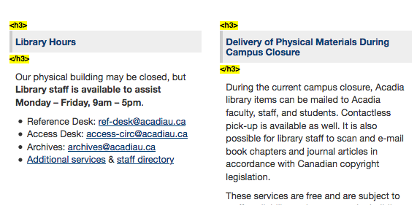

Note than an invisible Heading 2 was added to the code:

<h2 class="invisible">Search the Library</h2>

Invisible headings are NOT recommended, and should be avoided. A visible Heading 2 ‘Search the Library’ should be added above the search bar. This is not the main title of the page, rather a main section, thus the Heading 2.

As well, there is a heading hierarchy issue in one of the blocks. In the What is Happening at the Library block there were Heading 5’s used under a Heading 3 title. This is incorrect, and the Heading 5s need to be changed to Heading 4s.

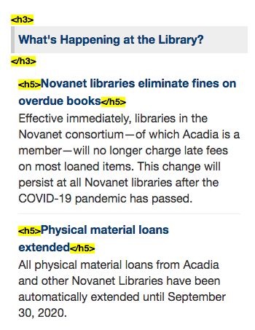

**Acadia Search **PRIORITY\*\***

Headings are missing, and problematic, on this page. First, there is no Heading 1 present, and this **MUST** be added. A Heading 1 Main Title, something like ‘Search Results’ needs to be added in a placement similar to the other pages. Then the Heading 3s present, must be changed to Heading 2s.

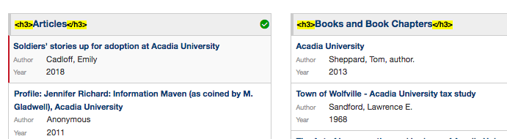

**Acadia Library Hours**

No issues noted.

**Acadia Loan Periods **PRIORITY\*\***

There were two issues noted that related to headings (and colour). First, the Policies Menu needs to be changed so that both words are in the Heading 2 code. This will solve the colour issue noted in that area as well.

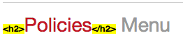

The second issue is that a Heading 2 title needs to be added before the list that is below the Main Title Heading 1. Currently, this may be confusing for both sighted, and non-sighted viewers. A Heading 2 title, such as ‘Loan Period Information’ should be added.

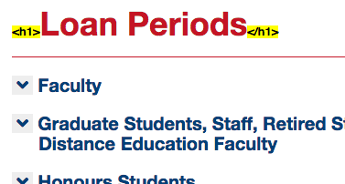

**Acadia Interlibrary Loans**

Note that a few Heading 4s were found, and they need to be removed. They are currently under the Heading 2 Information for Students, Faculty, Staff and Retired Faculty. They are noted below:

<div class="toggler"> How much does it cost? </div>

<h4>Loan</h4>

<h4>Photocopy</h4>

<h4>Other</h4>

<div class="toggler"> Fines and Charges </div> <div class="accordion"><div>

<h4>Overdue materials</h4>

<h4>Lost or damaged items</h4>

**Acadia What's Happening **PRIORITY\*\***

There are heading hierarchy issues noted on this page. The main title Heading 1 is correct, but then all item headings need to be changed from a Heading 3 to a Heading 2 (<h2>).

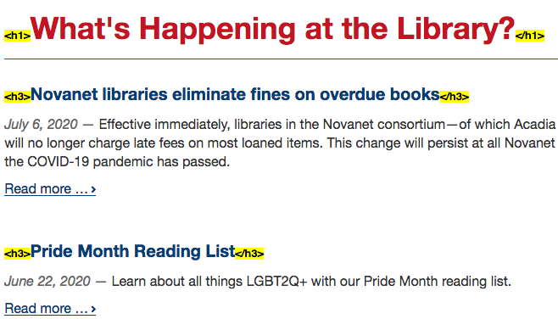

It is also recommended that, if possible, a Heading 2 or 3 be added to above the Twitter widget. This would give users without sight more information about that widget, in terms of whether they want to access it or not.

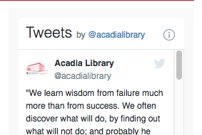

**Acadia Feedback (Contact Us)**

No issues noted.

**Acadia Our People **PRIORITY\*\***

The headings on this page are well done. One addition should be considered. Under the H2 Meet the Library Support Staff, each name should be given a Heading 3 (<h3>), so this section is consistent with the other section.

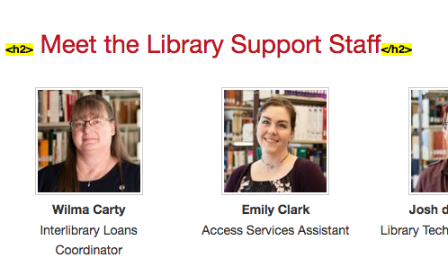

**Acadia Finding Things (Locations)**

No issues noted.

#### Tables

##### Importance and Users Impacted

Tables should only be used in web pages when they hold data. They should not be used for design or layout purposes. Users, particularly screen reader users who are blind, Deaf-Blind or have low vision, who can’t see the content in the tables, expect data to be in them. So, when they are used for layout and design, it is a confusing experience.

##### Findings

**Acadia Scholar Landing**

No issues noted.

**Acadia Scholar Profiles**

No issues noted with the table code itself. However, there was an issue noted by the tester who had a cognitive disability. A table should be reconsidered, and possibly a grid used instead. They noted:

“…full screen the layout is fully accessible and very clear to read and identify information. However, when the page is in split screen, with this word document for example, the department and position words go linear instead of one above the other to all fit in one (smaller) screen. This would be helpful; except they all overlap each other making it hard to read. It would probably be more efficient if you simply had to scroll to read more names. I know many students, including myself are always using the split screen function, so this may be something worthwhile to look into.”

**Acadia Scholar Theses Search Results**

No issues noted.

**Acadia Scholar Help**

No issues noted.

**Acadia Scholar Contact**

No issues noted.

**Acadia Scholar Thesis Example**

No issues noted.

**Acadia Scholar Advanced Search**

No issues noted.

**Chipman's Corner Digital Collections **PRIORITY\*\***

There is a table used for the information on this page. This table needs to be removed, because it is currently only being used for design and layout. The table is causing extra effort, and may be causing confusion, for screen reader users.

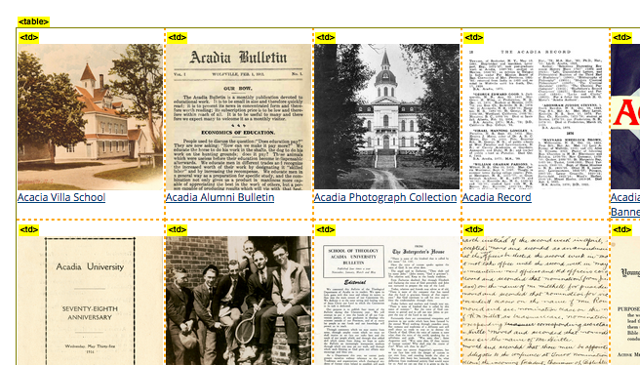

**Chipman's Corner Image Record**

No issues noted.

**Chipman's Corner Document Record**

No issues noted.

**Acadia Library Home**

No issues noted.

**Acadia Search**

No issues noted.

**Acadia Library Hours **PRIORITY\*\***

There were three tables used on this page. The tables need to be removed, as they are not correctly coded, unnecessary for the information, and are time consuming for screen reader users to navigate.

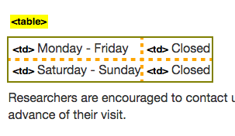

**Acadia Loan Periods **PRIORITY\*\***

See the note about table length under the Acadia Finding Things (Location) section. Note that on this page the length isn’t an issue with the tables, but the information may be easier to comprehend in lists.

**Acadia Interlibrary Loans**

No issues noted.

**Acadia What's Happening**

No issues noted.

**Acadia Feedback (Contact Us) **PRIORITY\*\***

See the note about table length under the Acadia Finding Things (Location) section.

**Acadia Our People**

No issues noted.

**Acadia Finding Things (Locations) **PRIORITY\*\***

The table code used is correct in form and function. However, there is **a lot** of information in these tables, and screen reader users without sight, and/or users with cognitive disabilities, may get tired of reading a **very long** table, another approach should be considered. Multiple lists could be used instead of a table, and then at least screen reader users would know how many items is in each list.

#### Images

##### Importance and Users Impacted

All images used in the website, including photographs, shapes, illustrations, maps, charts, etc., should be accessible to all readers. For screen reader users, images must be marked in the html code, as either important or non-important.

Screen reader users want to use their time accessing important images, so non-important images, such as those used for decoration, are marked with code that makes them invisible, so the screen reader user can ignore them. A null, or two quotes, is put in the alt attribute to signify this, such as alt="".

Important images may be regular images, images with text, and/or linked images. They add to the content, and/or context, of the text in some way. For important images, a short or long alternative text (alt) description must be provided that describes the image, and its importance.

If the image can be described in under 40-50 words, then this description is put in the alt attribute area. For example, <img src="images/importantimage.jpg" alt="explain the image as briefly as possible and only use a maximum of 40-50 words" />. If the image requires more description, the different techniques must be employed. Note that if an image is described in the text above or below it, and/or it is described in the caption, it likely still needs an alt text description to ensure all readers can access the information in it.

##### Findings

**Acadia Scholar Landing **PRIORITY\*\***

The images used in the show need to have a short description added to each of them, so all users get information about them.



**Acadia Scholar Profiles**

No issues noted.

**Acadia Scholar Theses Search Results **PRIORITY\*\***

There is a full alternative text description located in every item. The problem with these is that they can get very long and potentially stall screen readers. In this case, on this page, it is recommended to use null alt text (“”) instead of a description. As long as the full title is noted in the linked text description, then no alt text is required here (a null is required). One last related item is to remove the title from each link, as these are rarely used.

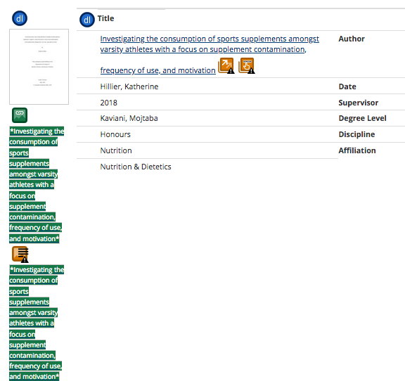

**Acadia Scholar Help**

No issues noted.

**Acadia Scholar Contac**

No issues noted.

**Acadia Scholar Thesis Example **PRIORITY\*\***

The Find It image does not have an alt attribute, but has a title. The title should be removed, and an alt attribute added with a description, something like ‘Find It! In the Acadia catalogue’.



**Acadia Scholar Advanced Search**

No issues noted.

**Chipman's Corner Digital Collection **PRIORITY\*\***

All images on this page are missing the alt attribute, and these must be remediated. Each needs an alt attribute added, and technically descriptive alt text should be added to each item. If descriptive text isn’t added, then a null alt must be used (“”).

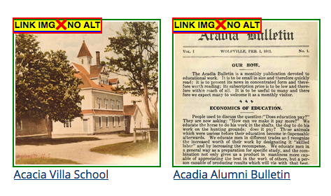

**Chipman's Corner Image Record **PRIORITY\*\***

This example is an image record and it needs to have an alt attribute, along with some description. If the description area on the page has described the image fully, including any text on it, then the alt attribute can be null (“”). If not, then a short description of the image is required.

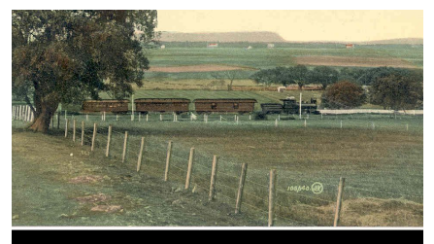

**Chipman's Corner Document Record**

One issue was noted in the function icons used in the function bar. The icons used are extremely small, and may be very hard to use for people with visual disabilities, and/or people with mobility disabilities. It is highly recommended that these be replaced with large icons.

These icons are also harder to use on mobile, due to their size. Ensure that these are checked and resized, so they are a minimum of 44 by 44 pixels, as required by WCAG 2.1 2.5.5 Target Size. Some consultants may disagree, but these are too small for many users, and are recommended for remediation.



**Acadia Library Home **PRIORITY\*\***

There was one related image issue noted. On the top logo image, a correct alt was applied. However, a device dependent handler was also applied to the image code:

<img src="./files/themes/vml2018_web/images/au_logo.png" alt="Acadia University" onclick="window.location.href='https://www2.acadiau.ca';" style="outline: red dashed 2px;">

It is not known why this was added, as it appears to be a straightforward link. However, when accessed, it goes to a completely different home page. Thus, this code should be reconsidered, and the onclick code should be removed.

**Acadia Search **PRIORITY\*\***

See the issue noted under the Acadia Library Home section.

**Acadia Library Hours **PRIORITY\*\***

See the issue noted under the Acadia Library Home section.

**Acadia Loan Periods **PRIORITY\*\***

See the issue noted under the Acadia Library Home section.

**Acadia Interlibrary Loans **PRIORITY\*\***

See the issue noted under the Acadia Library Home section.

**Acadia What's Happening **PRIORITY\*\***

See the issue noted under the Acadia Library Home section.

**Acadia Feedback (Contact Us) **PRIORITY\*\***

See the issue noted under the Acadia Library Home section.

**Acadia Our People **PRIORITY\*\***

See the issue noted under the Acadia Library Home section.

**Acadia Finding Things (Locations) **PRIORITY\*\***

See the issue noted under the Acadia Library Home section.

#### ARIA Code

##### Importance and Users Impacted

ARIA code is used primarily by screen reader users, and to a much lesser extent by voice recognition users. This code aids in navigation of web pages, and is sometimes required by WCAG. ARIA code has been mentioned elsewhere in this report, such as aria-label in the Calendar Section. Note that ARIA should never be used **instead** of HTML code, unless there is no other option.

There are different types of ARIA code that can be used on web pages. One ARIA element is landmarks, or roles, and these should be used on all web pages. Landmarks are invisible signposts in the code that are used by many screen reader users, and some voice recognition users.

With HTML 5, we can add important landmarks to note areas of the page in the code, such as <header>, <nav>, <main> and <footer> (a minimum should be header, footer and main). This code should also be mapped to ARIA roles, such as role=”banner”,role="navigation", role="main" and role="contentinfo", for full functionality. It is also recommended that the role ‘form’ be used as well.

It is recommended that the code include full landmarks to indicate page layout. This was added to the recent update to WCAG 2.1. Even though these are considered at the ‘gold level’, it is recommended they be included in the code.

ARIA can also be used to alert the user to potential changes or dynamic areas. For example, in accordion drop downs, they have the capability of changing from closed to open, and ARIA code should be used to note that to those users.

##### Findings

**Acadia Scholar Landing **PRIORITY\*\***

There is a HTML 5 header and footer, as well as two navigation elements, but there is only one role, banner. It is recommended that ARIA roles be added to the page, and these include contentinfo, navigation, search, and main.

**Acadia Scholar Profiles **PRIORITY\*\***

There is a HTML 5 header and footer, but there is only one role, banner. It is recommended that ARIA roles be added to the page, and these include contentinfo, search, and main.

**Acadia Scholar Theses Search Results **PRIORITY\*\***

ARIA hidden is used in two places, on the filter and sort by relevance icons. This ARIA hidden code should be avoided, unless there is no other alternative, because it makes this element invisible to screen reader users, and voice control users. In this case, if the icon is being called by the CSS then no hidden code or alt text is needed, because it is already invisible to screen reader users. This hidden code should be avoided, because it can, in some instances, make other content hidden as well.

There is a HTML 5 header, footer and aside, but there is only one role, banner. It is recommended that ARIA roles be added to the page, and these include contentinfo, aside, search, and main.

**Acadia Scholar Help **PRIORITY\*\***

There is a HTML 5 header and footer, but there is only one role, banner. It is recommended that ARIA roles be added to the page, and these include contentinfo, search, and main.

**Acadia Scholar Contact **PRIORITY\*\***

There is a HTML 5 header and footer, but there is only one role, banner. It is recommended that ARIA roles be added to the page, and these include contentinfo, search, and main.

**Acadia Scholar Thesis Example **PRIORITY\*\***

There is a HTML 5 header and footer, but there is only one role, banner. It is recommended that ARIA roles be added to the page, and these include contentinfo, search, and main.

ARIA hidden is used for the bookmark element, Add to Bookmark. This is used for the icon that is present here:

<span class="icon glyphicon glyphicon-plus" aria-hidden="true"></span>

Add to Bookmark</button>



This ARIA hidden code should be avoided, unless there is no other alternative, because it makes this element invisible to screen reader users, and voice control users. In this case, if the icon is being called by the CSS then no hidden code or alt text is needed, because it is already invisible to screen reader users. This hidden code should be avoided, because it can, in some instances, make other content hidden as well.

**Acadia Scholar Advanced Search **PRIORITY\*\***

There is a HTML 5 header and footer, but there is only one role, banner. It is recommended that ARIA roles be added to the page, and these include contentinfo, search, and main.

**Chipman's Corner Digital Collection **PRIORITY\*\***

There is a HTML 5 header and footer, but there is only one role, banner. It is recommended that ARIA roles be added to the page, and these include contentinfo, search, and main.

**Chipman's Corner Image Record **PRIORITY\*\***

There is a HTML 5 header, footer and aside, but there is only one role, banner. It is recommended that ARIA roles be added to the page, and these include contentinfo, aside, search, and main.

**Chipman's Corner Document Record **PRIORITY\*\***

There is a HTML 5 header, footer and aside, but there is only one role, banner. It is recommended that ARIA roles be added to the page, and these include contentinfo, aside, search, and main.

**Acadia Library Home *SECONDARY PRIORITY\***

There is HTML 5 code marking navigation areas, an aside, and header and footer areas. However, it is recommended that ARIA roles be added, even though they could be considered redundant. All applicable ARIA roles should be present, matching to the HTML 5 ones already there.

**Acadia Search *SECONDARY PRIORITY\***

See the HTML 5 and ARIA issue noted in the Acadia Library Home section.

**Acadia Library Hours *SECONDARY PRIORITY\***

See the HTML 5 and ARIA issue noted in the Acadia Library Home section.

**Acadia Loan Periods *SECONDARY PRIORITY\***

See the HTML 5 and ARIA issue noted in the Acadia Library Home section.

**Acadia Interlibrary Loans *SECONDARY PRIORITY\***

See the HTML 5 and ARIA issue noted in the Acadia Library Home section.

**Acadia What's Happening *SECONDARY PRIORITY\***

See the HTML 5 and ARIA issue noted in the Acadia Library Home section.

**Acadia Feedback (Contact Us) *SECONDARY PRIORITY\***

See the HTML 5 and ARIA issue noted in the Acadia Library Home section.

**Acadia Our People *SECONDARY PRIORITY\***

See the HTML 5 and ARIA issue noted in the Acadia Library Home section.

**Acadia Finding Things (Locations) *SECONDARY PRIORITY\***

See the HTML 5 and ARIA issue noted in the Acadia Library Home section.

#### Lists

##### Importance and Users Impacted

Proper list code must be used, so that all users can access the content in the list areas. This especially applies to screen reader users, who are Deaf-Blind, blind or have low vision, and some voice control users.

##### Findings

**Acadia Scholar Landing**

No issues found.

**Acadia Scholar Profiles**

No issues found.

**Acadia Scholar Theses Search Results *SECONDARY PRIORITY\***

Description list code (<dl>) is used in the description area, as shown below.

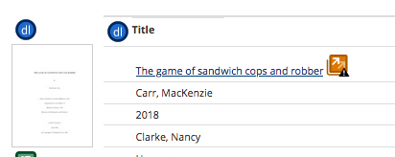

In my personal view, this is an incorrect use of the code, which is used for lists of items that are in a similar class. For example, multiple definitions of a word. It is recommended that this be changed to regular list code (<ul> or <ol>).

**Acadia Scholar Help**

No issues found.

**Acadia Scholar Contact**

No issues found.

**Acadia Scholar Thesis Example *SECONDARY PRIORITY\***

Description list code (<dl>) is used in the description area, as shown below.

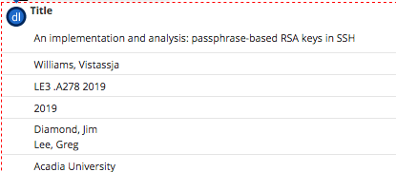

In my personal view, this is an incorrect use of the code, which is used for lists of items that are in a similar class. For example, multiple definitions of a word. It is recommended that this be changed to regular list code (<ul> or <ol>).

**Acadia Scholar Advanced Search**

No issues found.

**Chipman's Corner Digital Collection**

No issues found.

**Chipman's Corner Image Record *SECONDARY PRIORITY\***

Description list code (<dl>) is used in the description area, as shown below.

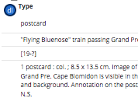

In my personal view, this is an incorrect use of the code, which is used for lists of items that are in a similar class. For example, multiple definitions of a word. It is recommended that this be changed to regular list code (<ul> or <ol>).

**Chipman's Corner Document Record *SECONDARY PRIORITY\***

Description list code (<dl>) is used in the description area, as shown below.

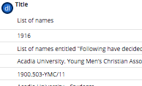

In my personal view, this is an incorrect use of the code, which is used for lists of items that are in a similar class. For example, multiple definitions of a word. It is recommended that this be changed to regular list code (<ul> or <ol>).

**Acadia Library Home**

No issues found.

**Acadia Search**

No issues found.

**Acadia Library Hours**

No issues found.

**Acadia Loan Periods**

No issues found.

**Acadia Interlibrary Loans**

No issues found.

**Acadia What's Happening**

No issues found.

**Acadia Feedback (Contact Us)**

No issues found.

**Acadia Our People**

No issues found.

**Acadia Finding Things (Locations)**

No issues found.

#### Search Mechanism

##### Importance and Users Impacted

Form elements, such as search mechanisms, must be accessible for all users, including screen reader users who are blind, Deaf-Blind or have low vision. Labels should be used on all form elements. Labels tell the user what the field is called and/or what to add in there, and these should link to the text next to each form item. So, the Username text next to a form element would match the Username label attached to that element in the code. As well, the label and ID should be the same, as in <label for="searchbox"> and <input id="searchbox">.

If a visible label can’t be added to the form, search box, etc., then one has to add code for viewers without sight. The most common method to add invisible label like information to the code today is to use aria-labelledby. It isn’t perfect by any means, but provides some information to screen reader users. Labels are not required for image, submit, reset, button, or hidden form controls.

Search buttons should be used, and they should use the <button> code, and not other code. If the <button> code is not used, many screen reader users without sight, and voice control users with sight may encounter severe issues with the use of that search input feature.

Many developers use placeholder text in search boxes to alert the user to how they can use that search or form element. It can be useful for voice control users, if it is paired with a label that has the exact same text. Although this is problematic, because that label text disappears as soon as words are entered the box, making it hard to reuse that search box in some situations. Users have the least issues when a visible label is used, without placeholder text.

While other consultants may disagree, it is recommended that placeholder text not be used in search or form boxes. Placeholders can cause many issues. This field may look ‘pre filled’, and it disappears when activated, which may cause confusion for elders, people with mobility disabilities and/or viewers with cognitive disabilities. As well, it doesn’t provide the same information to screen reader, or voice recognition, users that labels do, and finally on a device keyboard the label is better, because it provides information without erasure.

##### Findings

**Acadia Scholar Landing **PRIORITY\*\***

The top search area needs a label added to it. Currently, there is no label attached and this makes the search box harder, or impossible, to use for many users, including screen reader users who are blind, Deaf-Blind or have low vision and/or voice control users.



There is an empty link located on the page, and it should be removed, as it can cause confusion for users without sight, and for voice control users. The same applies to the empty button below.

<a href="records-by-year"></a>

<button type="button" data-toggle="collapse" data-target="#navbar-collapse-1" class="navbar-toggle"><span class="icon-bar"><span class="icon-bar"><span class="icon-bar"></button>

**Acadia Scholar Profiles **PRIORITY\*\***

The top search area needs a label added to it. Currently, there is no label attached and this makes the search box harder, or impossible, to use for many users, including screen reader users who are blind, Deaf-Blind or have low vision and/or voice control users.



A second search box also lacks a label, and a descriptive label needs to be added to it.

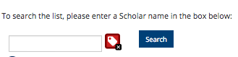

The Advanced Search link under the search box is also problematic. The colours should be checked in the CSS file, as they may be problematic for some people who use their own CSS stylesheet. Some might see the link as light on light, which may be problematic.

There is an empty button that needs to be removed:

<button type="button" data-toggle="collapse" data-target="#navbar-collapse-1" class="navbar-toggle"><span class="icon-bar"><span class="icon-bar"><span class="icon-bar"></button>

One other thing to note about the search on this page, came from the tester with a cognitive disability. They found that the search could only find exact matches, and this should be reconsidered:

“Clear and simple [search and results]. However, if you spell a name wrong, no search results come up. Even if you search Mar instead of Mark there are no results. Partial names bringing up results may be helpful if students misspell last names. However, it is easy for the student to look over their spelling.”

The tester with hearing and visual disabilities, who used two different screen readers noted another issue. When they clicked the link to see who that person supervised, or when they searched for a name in the search box:

“The page needs more clarity and I want to know the names of the people Stewart supervised not just their work.”

**Acadia Scholar Theses Search Results **PRIORITY\*\***

There is an empty button that needs to be removed:

<button type="button" data-toggle="collapse" data-target="#navbar-collapse-1" class="navbar-toggle"><span class="icon-bar"><span class="icon-bar"><span class="icon-bar"></button>

See the issue with the main search area label, and the one with the Advanced Search colours, in the Acadia Scholar Profiles area.

**Acadia Scholar Help **PRIORITY\*\***

There is an empty button that needs to be removed:

<button type="button" data-toggle="collapse" data-target="#navbar-collapse-1" class="navbar-toggle"><span class="icon-bar"><span class="icon-bar"><span class="icon-bar"></button>

See the issue with the main search area label, and the one with the Advanced Search colours, in the Acadia Scholar Profiles area.

**Acadia Scholar Contact **PRIORITY\*\***

See the issue with the main search area label, and the one with the Advanced Search colours, in the Acadia Scholar Profiles area.

**Acadia Scholar Thesis Example **PRIORITY\*\***

There is fieldset code used incorrectly, as there is no form element in that area, and it should be removed.

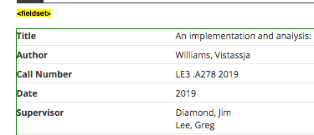

A label is missing for this search element, and one needs to be added.

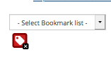

See the issue with the main search area label, and the one with the Advanced Search colours, in the Acadia Scholar Profiles area. See Acadia Scholar Advanced Search for more information on the empty button.

**Acadia Scholar Advanced Search **PRIORITY\*\***

There is a label used for ‘Search by’ that should be removed.

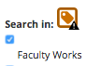

There is also an empty button that needs to be removed:

<button type="button" data-toggle="collapse" data-target="#navbar-collapse-1" class="navbar-toggle"><span class="icon-bar"><span class="icon-bar"><span class="icon-bar"></button>

See the issue with the main search area label, and the one with the Advanced Search colours, in the Acadia Scholar Profiles area.

**Chipman's Corner Digital Collection **PRIORITY\*\***

There is an empty button that needs to be removed:

<button type="button" data-toggle="collapse" data-target="#navbar-collapse-1" class="navbar-toggle"><span class="icon-bar"><span class="icon-bar"><span class="icon-bar"></button>

See the issue with the main search area label, and the one with the Advanced Search colours, in the Acadia Scholar Profiles area.

**Chipman's Corner Image Record **PRIORITY\*\***

There is an empty button that needs to be removed:

<button type="button" data-toggle="collapse" data-target="#navbar-collapse-1" class="navbar-toggle"><span class="icon-bar"><span class="icon-bar"><span class="icon-bar"></button>

See the issue with the main search area label, and the one with the Advanced Search colours, in the Acadia Scholar Profiles area.

There is also an empty form label, which needs to be removed.

label style="background: transparent none repeat scroll 0% 0%; border: medium none; margin: 0px; padding: 0px; position: static;">

**Chipman's Corner Document Record **PRIORITY\*\***

There is fieldset code used incorrectly, as there is no form element in that area, and it should be removed.

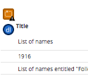

There is an empty button that needs to be removed:

<button type="button" data-toggle="collapse" data-target="#navbar-collapse-1" class="navbar-toggle"><span class="icon-bar"><span class="icon-bar"><span class="icon-bar"></button>

See the issue with the main search area label, and the one with the Advanced Search colours, in the Acadia Scholar Profiles area.

**Acadia Library Home *SECONDARY PRIORITY\***

The main search bar is well placed, and is easy to access by the majority of users. Note that placeholder text is present.



Placeholder text is not recommended for a variety of reasons. It can be hard to use by people with visual and/or cognitive disabilities. This should be reconsidered, if at all possible.

**Acadia Search**

No issues noted.

**Acadia Library Hours**

No issues noted.

**Acadia Loan Periods**

No issues noted.

**Acadia Interlibrary Loans**

No issues noted.

**Acadia What's Happening**

No issues noted.

**Acadia Feedback (Contact Us)**

No issues noted.

**Acadia Our People**

No issues noted.

**Acadia Finding Things (Locations) *SECONDARY PRIORITY\***

There were three empty buttons noted, and if these are not being used by a pop up or script, they should be removed.

#### Search Results

##### Importance and Users Impacted

Search results must be accessible, and easy to use by all users, whether they have a disability or not. Only pages that have search results are listed below.

##### Findings

**Acadia Scholar Landing **PRIORITY\*\***

Issues were noted. The first involved the + and – facet filter mechanisms also noted in the Acadia Scholar Theses Search Results below. This screen print shows the mechanisms:

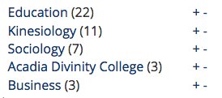

The tester with ADHD noted that they were confusing, and these should be replaced so all users can use this type of facet add or delete mechanism:

“Yes, categories made sense – but.I don’t understand what the + and - signs are for next to the filter, no matter what I press, it removes filters and then I don’t know how to get back.”

As well, this tester also noted that the date filter was hard to use.

“Frustrating at first, genius once I figured it out. I didn’t know how to change the date range but then I notices the little triangles that look like indicators you could slide, the didn’t slide so I clicked and watched what happened, then I realized you could select the bar range, then expand or decrease by clicking – trial and error but actually really cool and I like it better than the calendar you have to find a date for.”

This filter mechanism may be problematic for some users. This tester provided two very good suggestions, one of which could help solve the date filter user for users with sight.

“1) I’d like a clear all filters option

2) A navigation document somewhere to show people how to navigate and filter (i.e. the filter by date) I checked the help section, and this seems to be for people submitting papers. I would put it someplace not intrusive because I like that there is no clutter. Personally, I would add it to the help section that already exists – a hyperlink to an info-graph”

The second issue noted was from the tester with mobility and migraine disabilities, who uses text to speech software to navigate pages. They were unable to use the date filter feature. This feature **MUST** be changed so all users can access it:

“The way you have to filter makes it inaccessible b/c my speech to text wont read the dates out loud when you toggle the graph. The filter did work though…the data filter is VERY inaccessible.”

The tester with autism did note the following, which may or may not be an issue related to Acadia’s system:

“The only thing that I did outside of what I asked to do, I clicked on two of the papers. I could access them on the website itself; however, if I tried to access it in Google Scholar, the paper will not show up. This might be an issue of Google Scholar, but I thought it might be good to bring this to light!”

The tester with ADHD noted one aspect about the search results, which should be considered:

“… the system recognizes punctuation as coming before a. so regardless of what letter it starts with, a title that has say “supporting…..” is going to come before “analogy of a …”

More major issues were noted with the search results page that was accessed for the Acadia Scholar Landing page. Two tests were done. One used the search box on that page, and the second used the Advanced Search link/page. There were many comments about the search results page from the last two testers.

The tester with hearing and visual disabilities, who used two different screen readers could access parts of the search results page, but then others associated with the filters were problematic. They reported not being able to access the Sort by options:

“JAWS: I clicked on it (Sort by Relevance) fine but there weren’t any other additional options so I don’t know what order they were refined in.”

“VoiceOver: it worked fine but no order was read.”

Noted that they could not access the Sort by Date feature:

“JAWS: I clicked on it just fine but I didn’t hear any options to set the date.”

“VO: I did this fine no options to set the date though.”

They tried a second search and noted:

“JAWS: I wasn’t able to put in the date so, No, the filter didn’t work.”

“VO: I didn’t hear the opportunity to put that date in.”

As mentioned with the tester who used text to speech software, the sort by date feature must be remediated, and a different script used. They also couldn’t access the sort by Masters feature at all:

“JAWS: This option was not read to me by my screen reader.”

“VO: this category was not read to me.”

As noted before, the way the filtering is done on this page has to be completely redone, so all users can access it.

They also noted that the many categories to refine the search were confusing and made a recommended suggestion:

“JAWS: Yes but they are not in any category , they’re just in a list at the end of the page.”

“VO: These are unclear. There should be a heading that says “Filter by”.

They also mentioned the placement of the sort facets in the code should change, as they are now read on iPhone at the bottom of the page:

“VO: They should put the categories and sort by list at the top of the page not at the bottom so one can filter easily without having to read all the article titles first.”

The tester with hearing and visual disabilities, who used two different screen readers went back again to do a different search, using the Advanced Search page. On this second test, they noted different barriers with the search results page. Their recommendation of reorganizing the page is **HIGHLY** recommended. Here are their comments after using this search results page, which can be applied to any Acadia results pages.

This tester mentions that headings need to be added. Headings are already present, and it is not known why they weren’t accessed. The tester makes the comment that people need to read the page over, and then use it. Thus, it is recommended that text be added below the Heading 1, Search Results, to note all the ways results can be filtered. This will improve the experience for everyone, and may solve many of the issues noted below by this tester.

“JAWS: it was not clear where each categories would be. I had to use my own reasoning to figure it out., moved on really quickly but there should have been headings stating what each combo box was for.”  
“VoiceOver: it was honestly confusing because I dint know where the abstract would be under. I had to navigate my way back to the top of the page to think about where the search filters could be. There should have been headings for clarity sake. It takes prior knowledge of online library research to understand where each search category could be. It also takes much thought.”

“JAWS: the results didn’t make sense until I was on the third article. Then it clicked to me that this was a result. There should have been a heading that said “result list”.i also don’t know why it read each article to me twice.”  
“VO: there should have been a heading before the search results list started to let me know that I was there. It is also reading the same article twice for reasons unknown to me.”

This tester found barriers when trying to narrow the results to a specific Thesis Supervisor:

“JAWS: No, I couldn’t do this because her name was not read to me. First of all, I found the list of supervisors at the bottom of the page because I knew I was looking for names but there should have been a heading at the before the list of names started so students can know what the names mean. I also didn’t get Susan Potters name read to me even about five others were.”  
“VO: I didn’t find this supervisor while tabbing through the page but what I found surprising is that Voice over will actually read the headings to me if I pressed VO+A which is the say all command. So when I did this just to check, I realized it did read “Thesis Supervisor”:. So I guess, before the student doing research starts tabbing through, they have to read the whole page first to know what’s on the page.”

The tester added:

“I think the structure of the page needs to be re-organised. They shouldn’t just put bandaid on it. They should start from scratch and reorganised it.

VO: same comment. I think they should reorganise the page from scratch.”

The tester with low vision noted a few issues with the search results page, including not being able to access the date filter area.

“The search experience using the search bar was simple. The box was easy to understand and the button prominently displayed. The search results made sense and was related to the query. The description was big enough, although some results in the search table chopped up long words due to the enlarged text size (For example, the word “Supervisor” was chopped up, with the “r” on a line below the rest of the word.”

“The categories to refine the search made sense, and I could easily tap them to sort. I sorted by Graduate Theses, but couldn’t tell whether it had worked or not as there is no label on the results that indicate them as graduate theses. I then sorted by Masters and was able to tell that it worked because each of the results had the label “Degree Level - Masters”. All the text was readable and navigation was simple.”

“I could not filter by date. The interface was unintuitive and I wasn’t able to tell how to operate it. I eventually figured out that the bars for each year could be touched, and then you can filter the results for that year, but I could not determine how to select multiple years. The bars were also not labelled so it was impossible to determine which year was which before touching them. This was a bad experience and I would not attempt searching by date again.”

However, this tester did note that the page itself was well laid out. However, they noted that they would have liked the Advanced Search link on the Landing page to be bigger and more noticeable:

“Overall this page is well thought out and designed. It is simple and clear to read even when enlarged. I really appreciate the clear design of the page, there is no superfluous pictures or funky text. The search results were easy to filter and further refine the search. One slight modification might be made to the “Advanced Search” button itself. It appears just as text, so it might be helpful to highlight that this is a button and make it a bit bigger so it is easier to see it and tap it.”

**Acadia Scholar Profiles**

No issues noted.

**Acadia Scholar Theses Search Results **PRIORITY\*\***

There were issues noted with the refinement facets on the left side of the page.

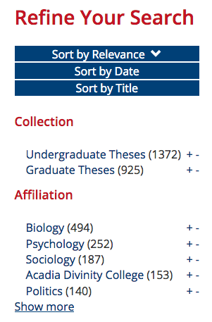

The facets that are present are very useful, However, if one uses them, there is no indication on the page that specific refinements have been used. For example, if Sort by Relevance, Date and/or Title are chosen, only a small arrow is present next to the refinement chosen. This indicator can be confusing for many users, as the refinements enacted are not noticeable.

As well, the plus and minus signs may be confusing to some viewers, and again there is no indication of what was chosen to be filtered, either on or off.

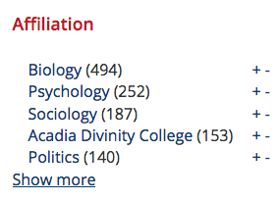

The Novanet interface provides an alternative that can be used that shows the filters enabled, as shown with the chosen Peer reviewed Journals filter enabled in the screen print below.

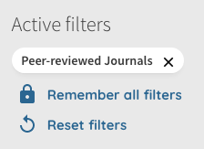

The other item noticed was the code used for each item in the search. Each item is given <dt> and <dd> code, as shown in the screen print below.

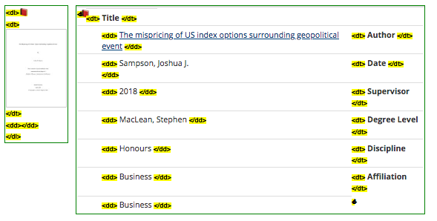

In the view of the consultant, this code has been used incorrectly. The <dl> tag defines a description list, and this is used on the left side. However, there is no list there. It is also used at the start of each item, such as Title in the screen print above. The <dl>, <dt> and <dd> code is not used correctly, because that code should be used for a list of separate items.

Each separate item should be given a <dt>, with more detailed information about that <dt> should be in <dd> code. One example is a grocery list of different items, such as apples, oranges, etc. The <dt> would be <dt>apple</dt>, and the <dd> under it would be <dd>Macintosh</dd> Then <dt>orange</dt>, and under it <dd>Navel</dd>, <dd>Blood</dd>. Here, the information presented is different, but it all belongs to one item, the Title in the screen print above.

See issues noted in the Acadia Scholar Landing section above, which also relate to these search results

**Acadia Search *SECONDARY PRIORITY\***

One issue noted was that the link Advanced Search was used for each category. If possible, this should be changed so that each is unique. For example, Database Advanced Search, Books and Book Chapters Advanced Search, etc.

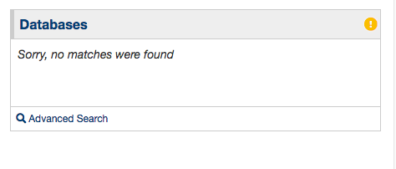

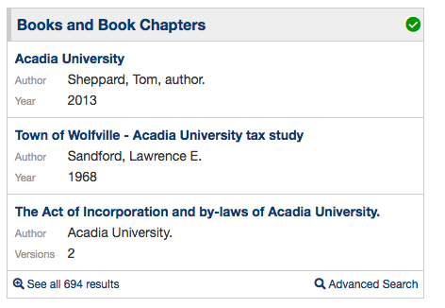

The tester with hearing and visual disabilities, who used two different screen readers found barriers when using the search results page (from the Acadia Library home area). It is not known exactly why this happened as there were headings present and they were usable.

“Can you find a subject guide relating to this term? JAWS: No, VO: No”

“JAWS: No, there were no headings for the categories so I don’t know what each are for.  
VO: The advanced search heading had a bunch of sub-headings, I think, that could not be read by tabbing. I think this why the difference between the search results were not read to me. It hink this the problem.”

“JAWS: there are tabbable stuff, they need to make headings for each category of results.   
VO: The website needs to be more organised and the subheadings need to be tababble. I think that is the solution.”

The search results page uses headings and everything under them is tabbable, for people who don’t use a mouse. The tester was recommending that the headings be linked to their results. Headings are usually not links, it is not recommended as they have a specific purpose as a title. No recommendations are made at this time.

#### CSS

##### Internal CSS

CSS needs to be located in external CSS files, not in the HTML files, so it can be updated in a consistent manner. Plus, those who use their own CSS style sheet can not always override CSS styling code in HTML, and it can cause problems for these viewers. CSS is present in the HTML code, and this should be removed, if possible, and put into a separate css file.

##### Findings

**Acadia Scholar Landing**

No issues noted.

**Acadia Scholar Profiles**

No issues noted.

**Acadia Scholar Theses Search Results**

No issues noted.

**Acadia Scholar Help**

No issues noted.

**Acadia Scholar Contact**

No issues noted.

**Acadia Scholar Thesis Example**

No issues noted.

**Acadia Scholar Advanced Search**

No issues noted.

**Chipman's Corner Digital Collection**

No issues noted.

**Chipman's Corner Image Record**

No issues noted.

**Chipman's Corner Document Record**

No issues noted.

**Acadia Library Home *SECONDARY PRIORITY\***

See the Acadia Finding Things (Locations) section.

**Acadia Search *SECONDARY PRIORITY\***

See the Acadia Finding Things (Locations) section.

**Acadia Library Hours *SECONDARY PRIORITY\***

See the Acadia Finding Things (Locations) section.

**Acadia Loan Periods *SECONDARY PRIORITY\***

See the Acadia Finding Things (Locations) section.

**Acadia Interlibrary Loans *SECONDARY PRIORITY\***

See the Acadia Finding Things (Locations) section.

**Acadia What's Happening *SECONDARY PRIORITY\***

See the Acadia Finding Things (Locations) section.

**Acadia Feedback (Contact Us) *SECONDARY PRIORITY\***

See the Acadia Finding Things (Locations) section.

**Acadia Our People *SECONDARY PRIORITY\***

See the Acadia Finding Things (Locations) section.

**Acadia Finding Things (Locations) *SECONDARY PRIORITY\***

**There are some areas, where CSS styling code has been inserted into the HTML code. For example:**

<img src="./files/themes/vml2018_web/images/au_logo.png" alt="Acadia University" onclick="window.location.href='https://www2.acadiau.ca';" style="outline: red dashed 2px;">

This kind of code needs to be moved to the CSS style sheet, so users who have their own stylesheets can use them without difficulty.

#### HTML Code Errors

##### Importance and Users Impacted

There should be no HTML code errors present on web pages, if possible. This makes the site better for people, as well as search engines. The NU html checker (<https://validator.w3.org/nu/>) should be used to find, and then fix, errors.

##### Findings

**Acadia Scholar Landing**

No issues noted.

**Acadia Scholar Profiles *SECONDARY PRIORITY\***

There were code errors noted on this web page. The code should validate, or be as close as possible. All errors should be checked and remediated. Note that some errors are noted in this report, so remediation should be done and then all pages should be rechecked for final errors to fix.

**Acadia Scholar Theses Search Results *SECONDARY PRIORITY\***

There were code errors noted on this web page. The code should validate, or be as close as possible. All errors should be checked and remediated. Note that some errors are noted in this report, so remediation should be done and then all pages should be rechecked for final errors to fix.

**Acadia Scholar Help *SECONDARY PRIORITY\***

There were code errors noted on this web page. The code should validate, or be as close as possible. All errors should be checked and remediated. Note that some errors are noted in this report, so remediation should be done and then all pages should be rechecked for final errors to fix.

**Acadia Scholar Contact *SECONDARY PRIORITY\***

There were code errors noted on this web page. The code should validate, or be as close as possible. All errors should be checked and remediated. Note that some errors are noted in this report, so remediation should be done and then all pages should be rechecked for final errors to fix.

**Acadia Scholar Thesis Example **PRIORITY\*\***

There were code errors noted on this web page. The code should validate, or be as close as possible. All errors should be checked and remediated. Note that some errors are noted in this report, so remediation should be done and then all pages should be rechecked for final errors to fix.

**Acadia Scholar Advanced Search *SECONDARY PRIORITY\***

There were code errors noted on this web page. The code should validate, or be as close as possible. All errors should be checked and remediated. Note that some errors are noted in this report, so remediation should be done and then all pages should be rechecked for final errors to fix.

**Chipman's Corner Digital Collection *SECONDARY PRIORITY\***

There were code errors noted on this web page. The code should validate, or be as close as possible. All errors should be checked and remediated. Note that some errors are noted in this report, so remediation should be done and then all pages should be rechecked for final errors to fix.

**Chipman's Corner Image Record *SECONDARY PRIORITY\***

There were code errors noted on this web page. The code should validate, or be as close as possible. All errors should be checked and remediated. Note that some errors are noted in this report, so remediation should be done and then all pages should be rechecked for final errors to fix.

**Chipman's Corner Document Record *SECONDARY PRIORITY\***

There were code errors noted on this web page. The code should validate, or be as close as possible. All errors should be checked and remediated. Note that some errors are noted in this report, so remediation should be done and then all pages should be rechecked for final errors to fix.

**Acadia Library Home *SECONDARY PRIORITY\***

There were code errors noted on this web page. The code should validate, or be as close as possible. All errors should be checked and remediated. Note that some errors are noted in this report, so remediation should be done and then all pages should be rechecked for final errors to fix.

**Acadia Search *SECONDARY PRIORITY\***

There were code errors noted on this web page. The code should validate, or be as close as possible. All errors should be checked and remediated. Note that some errors are noted in this report, so remediation should be done and then all pages should be rechecked for final errors to fix.

**Acadia Library Hours *SECONDARY PRIORITY\***

There were code errors noted on this web page. The code should validate, or be as close as possible. All errors should be checked and remediated. Note that some errors are noted in this report, so remediation should be done and then all pages should be rechecked for final errors to fix.

**Acadia Loan Periods *SECONDARY PRIORITY\***

There were code errors noted on this web page. The code should validate, or be as close as possible. All errors should be checked and remediated. Note that some errors are noted in this report, so remediation should be done and then all pages should be rechecked for final errors to fix.

**Acadia Interlibrary Loans *SECONDARY PRIORITY\***

There were code errors noted on this web page. The code should validate, or be as close as possible. All errors should be checked and remediated. Note that some errors are noted in this report, so remediation should be done and then all pages should be rechecked for final errors to fix.

**Acadia What's Happening *SECONDARY PRIORITY\***

There were code errors noted on this web page. The code should validate, or be as close as possible. All errors should be checked and remediated. Note that some errors are noted in this report, so remediation should be done and then all pages should be rechecked for final errors to fix.

**Acadia Feedback (Contact Us) *SECONDARY PRIORITY\***

There were code errors noted on this web page. The code should validate, or be as close as possible. All errors should be checked and remediated. Note that some errors are noted in this report, so remediation should be done and then all pages should be rechecked for final errors to fix.

**Acadia Our People *SECONDARY PRIORITY\***

There were code errors noted on this web page. The code should validate, or be as close as possible. All errors should be checked and remediated. Note that some errors are noted in this report, so remediation should be done and then all pages should be rechecked for final errors to fix.

**Acadia Finding Things (Locations) *SECONDARY PRIORITY\***

There were code errors noted on this web page. The code should validate, or be as close as possible. All errors should be checked and remediated. Note that some errors are noted in this report, so remediation should be done and then all pages should be rechecked for final errors to fix.

## **Disclaimer**

* The Client acknowledges that the requirements of the Accessibility for Manitobans Act (AMA), Accessibility Act of Nova Scotia (AA), Accessibility for Ontarians with Disabilities Act (AODA), Revised Section 508 (Refresh), and/or any other American and/or Canadian provincial and/or federal laws, rules, codes, ordinances and regulations as they apply to the services provided, will be subject to various and possibly contradictory interpretations.
* The evaluation of systems, practices, workflows, policies, materials, including, but not restricted to, web sites, social media postings, documents, maps, signage, apps and similar or unique electronic, digital or print entities, etc. and/or content, to ascertain whether they conform to general accessibility best practices and/or recommendations, and/or Revised Section 508 (Refresh), and/or WCAG 2.0 and/or WCAG 2.1 and/or WCAG 2.2 is done by The Consultant.
* Some criterion under Revised Section 508 (Refresh) and/or WCAG 2.0 and/or WCAG 2.1 and/or WCAG 2.2 can be checked with automated online checkers. However, most criterion rely exclusively, or partially, on manual checking by The Consultant. A Pass/Fail under Revised Section 508 (Refresh), and/or WCAG 2.0 and/or WCAG 2.1 and/or WCAG 2.2 criterion and/or more general accessibility recommendations are decided upon by The Consultant using its reasonable professional efforts and judgment to interpret applicable accessibility requirements for Revised Section 508 (Refresh) and/or WCAG 2.0 and/or WCAG 2.1 and/or WCAG 2.2 and/or general accessibility best practices and/or recommendations.
* Other Consultants may vary in their opinions on the decision of a Revised Section 508 (Refresh) and/or WCAG 2.0 and/or WCAG 2.1 and/or WCAG 2.2 criterion Pass/Fail and the rationale behind it/them, when they complete manual assessments of the guidelines of said Client systems, practices, workflows, policies, materials and/or content, as noted above.
* Other Consultants may vary in their opinions on general accessibility best practices and/or recommendations and the rationale behind it/them, when they complete manual assessments of said Client systems, practices, workflows, policies, materials and/or content, as noted above.
* While The Consultant makes every effort to audit all said Client systems, practices, workflows, policies, materials and/or content, as noted above, during the contract period, there may be items that were inadvertently left out of reports, audits, and similar.
* The Consultant may provide seminars, talks, courses, panel discussions, training sessions, webinars, workshops and/or similar entities based on, and not exclusive to, general and/or specific accessibility best practices and/or recommendations, The Consultant’s experiences and/or WCAG 2.0 and/or WCAG 2.1 and/or WCAG 2.2 and/or Revised Section 508 (Refresh). These are decided upon by The Consultant using its reasonable professional efforts and judgment to interpret applicable accessibility requirements for Revised Section 508 (Refresh) and/or WCAG 2.0 and/or WCAG 2.1 and/or WCAG 2.2 and/or general and/or specific accessibility best practices and/or recommendations and/or The Consultant’s experience. Other Consultants may vary in their opinions and the rationale behind it/them, when they provide similar services.
* The Consultant will use its reasonable professional efforts and judgment to interpret applicable accessibility requirements in effect as of the date of the work and as they apply to the accessibility consulting services. The Consultant, however, cannot and does not warrant or guarantee that the work done for The Client will comply with all possible interpretations of the accessibility requirements and/or the requirements of the Accessibility for Manitobans Act (AMA), Accessibility Act of Nova Scotia (AA), Accessibility for Ontarians with Disabilities Act (AODA), Revised Section 508 (Refresh) and/or any other American and/or Canadian provincial and/or federal laws, rules, codes, ordinances and regulations as they apply to the services provided, and The Consultant shall, accordingly, not have any liability to The Client in connection with same.

## Copyright

© Copyright 2020 Access Changes Everything. This report, and the recommendations contained in it, are only to be used by The Client for the purpose contracted. No other use of this report is authorized. This report is not to be distributed, or used by any other business, organization, individual, vendor, 3rd party or organization, member of the public, without the express written permission from Access Changes Everything